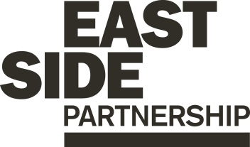

Job Description ESP/ESAPAA22

Project: EastSide Arts

Job Title: Production & Admin Assistant

Location: EastSide Partnership, Newtownards Road, Belfast

Reports to: EastSide Arts Manager

Terms and conditions

Salary: £18,333 per annum (based on 35 hour week), on a scale of points 1 – 6 + 7.5% pension.

Contract: This is a permanent role. Job subject to 6-month probation period.

The post is a grant funded position. Grant funding has currently been secured for this post until June 2025.

Holidays: 25 days per year plus statutory holidays.

Hours of work: 35 hours per week but willingness to work flexible hours including evenings and weekends essential.

Training: A range of skills development and training opportunities will be provided as part of the role.

EastSide Partnership is only able to accept applications from those individuals who are currently eligible to work in the UK. We will only interview those applicants who appear, from the information provided, to be the most suitable in terms of the person specification.

Main Purpose of Job
To assist in the planning and delivery of EastSide Arts’ year-round programme of events, including the annual EastSide Arts & Writers Symposium festivals, open access creative programmes and targeted engagement projects.
_________________________________________________________
Summary of responsibilities and personal duties

1. Provide administrative and production support to the Manager and Community Engagement Officer in the planning and delivery of EastSide Arts events and programmes.

2. Support venue booking for events and programmes, including liaising with artists/facilitators to establish requirements, liaising with event providers, arranging hospitality where required, setting up basic equipment, carrying out contractual administration and supporting invoicing and payment processes.

3. Assist with booking artists and facilitators for events, carrying out contractual administration and supporting invoicing and payment processes.

4. Work as part of the Front of House Team for events, supporting the volunteer team and Front of House Manager.

5. Assist with marketing administration including: collating content for festival and event promotional materials; liaising with designers and drafting content for social media platforms and website.

6. Assist the Manager and Community Engagement Officer in the completion of funding applications, event evaluation and reports.

7. Attend meetings/events relating to EastSide Arts as required, representing EastSide Arts & EastSide Partnership.

8. Ensure that Health and Safety procedures and policies are being followed at all times during EastSide Arts activities in accordance with our Health and Safety Policy

9. Undertake any other reasonable duties as required

Person Specification

Essential Criteria

Qualifications
- 4 GCSE’s, A*-C, to include English and Maths

Experience

A minimum of 6 months’ experience within the last 3 years of:
- Working in a busy environment with lots of demands on your time
- Using Microsoft Office suite including Word, Excel, Outlook
- Working in a role where you deal with lots of different people
- Experience of planning and delivering events

Skills
- Excellent organisational and time management skills
- Excellent interpersonal, oral and written communication skills dealing with a range of internal and external stakeholders
- Ability to adapt and work effectively under pressure, prioritise and manage workload and meet deadlines
- Ability to work accurately with excellent attention to detail

Disposition
- Confident in managing and completing tasks
- Self-motivated and initiative taking
- Thrives in a busy environment
- Enjoys meeting and working with different types of people

Knowledge and Values
- Knowledge of and interest in the work of EastSide Arts
- Understanding of and willingness to work within the ethos and values of EastSide Partnership

Circumstances
- Must be available to work during the 2022 EastSide Arts Festival (4th -14th August)

Desirable Criteria

Experience
- Experience of working in an event or production role
- Experience of working in an administrative support role
- Experience in a Front of House role at live events and/or workshops
- Experience of using:
  - Social media
  - Mailchimp
  - Design packages e.g. Photoshop/ InDesign, Canva or similar

Equal Opportunities Monitoring Form ESP/ESAPAA22

Ref No: ESP/ESAPAA22 Private & Confidential

We are an Equal Opportunity Employer. We do not discriminate on grounds of religious belief or political opinion. We practice equality of Opportunity in employment and select the best person for the job.

To demonstrate our commitment to equality of opportunity in employment we need to monitor the community background of our applicants and employees, as required by the Fair Employment and Treatment (NI) Order 1998.

Regardless of whether we practice religion, most of us in Northern Ireland are seen as Catholic or Protestant. We are therefore asking you to indicate your community background by ticking the appropriate box below.

I am a member of the Protestant community

I am a member of the Roman Catholic community

I am a member of neither the Protestant nor Roman
Catholic community

Please indicate whether you are: Female

Male

If you do not complete this questionnaire, we are encouraged to use the “residuary” method, which means that we can make a determination on the basis of personal information on file/application form.

Note: It is a criminal offence under the legislation for a person to “give false information in connection with the preparation of the monitoring return”.

Application Process ESP/ESAPAA22

Application
- Completed applications must arrive by 3pm on Wednesday 25th May 2022

- Applications will only be accepted by email to gillian@eastsidepartnership.com and will be acknowledged by email. If not acknowledged please contact Gillian on 028 90451900

- Application MUST be by letter outlining how you meet all of the criteria in the person specification. The letter must be no longer than 2 x A4 pages, minimum font size 11. You may also include a CV (max 2 x A4 pages, minimum font size 11) but please ensure that if you enclose a CV, you cover how you meet all criteria as detailed in the person specification, in your letter

- To be accepted the application MUST include the monitoring form

- Only information contained in the letter and accompanying CV will be taken into account, so please ensure that you include all relevant information. Any content exceeding the 2 x A4 limit will be disregarded

- We may only interview those applicants who appear, from the information provided, to be the most suitable in terms of the person specification provided.

Equal Opportunities
- EastSide Partnership is an equal opportunities employer. EastSide Partnership does not permit unlawful discrimination of any kind against any person on grounds which include gender, sexual orientation, marital status, religious belief or political opinion, race or disability. Unlawful discrimination is defined as treating a person less favourably than others are, or would be treated in the same or similar circumstances.

Canvassing
- Canvassing in any form will, if proved to the satisfaction of EastSide Partnership, disqualify a candidate for the appointment

Interviews
- Interviews will be held in person on Wednesday 1st June. Please ensure your availability for interview on this date prior to application, as it will not be possible to arrange an alternative date

Job Description
- The duties outlined in the Job Description serve as a guide to the current and major responsibilities of the post. These will inevitably vary as the role develops and the Job Description will be reviewed on a regular basis. Changes will be subject to consultation with the post holder.

Background Information

EastSide Partnership is a local charity leading the regeneration of east Belfast. Working alongside other community-based organisations, elected representatives, statutory agencies and local businesses, EastSide Partnership delivers a wide variety of projects with a clear mission to ‘make east Belfast a better place’ for residents, businesses and visitors.

Our vision is that east Belfast will be a great place where:
- Residents enjoy good health and well being
- Education is valued and high standards achieved
- Tourism, arts and hospitality are thriving

EastSide Partnership aims to:
- Create an east Belfast that is a thriving cultural hub, where the arts are valued, creativity is for everyone and people are connected with each other and the wider world through EastSide Arts
- Promote the use and development of green open spaces, parks, rivers and off-road transport routes in east Belfast through EastSide Greenways including Connswater Community Greenway
- Help and support children in east Belfast to develop their abilities, reach their potential and experience success, whatever their background through EastSide Learning
- Contribute to the regeneration of east Belfast through the strategic acquisition, development and management of sites and properties through EastSide Property
- Coordinate and deliver responsible, sustainable and impactful culture-led regeneration, pushing boundaries to put east Belfast on the map through EastSide Tourism
- Raise awareness and help alleviate the impact of poverty in inner east Belfast through the Scaffolding Project

For more information please visit www.eastsidepartnership.com
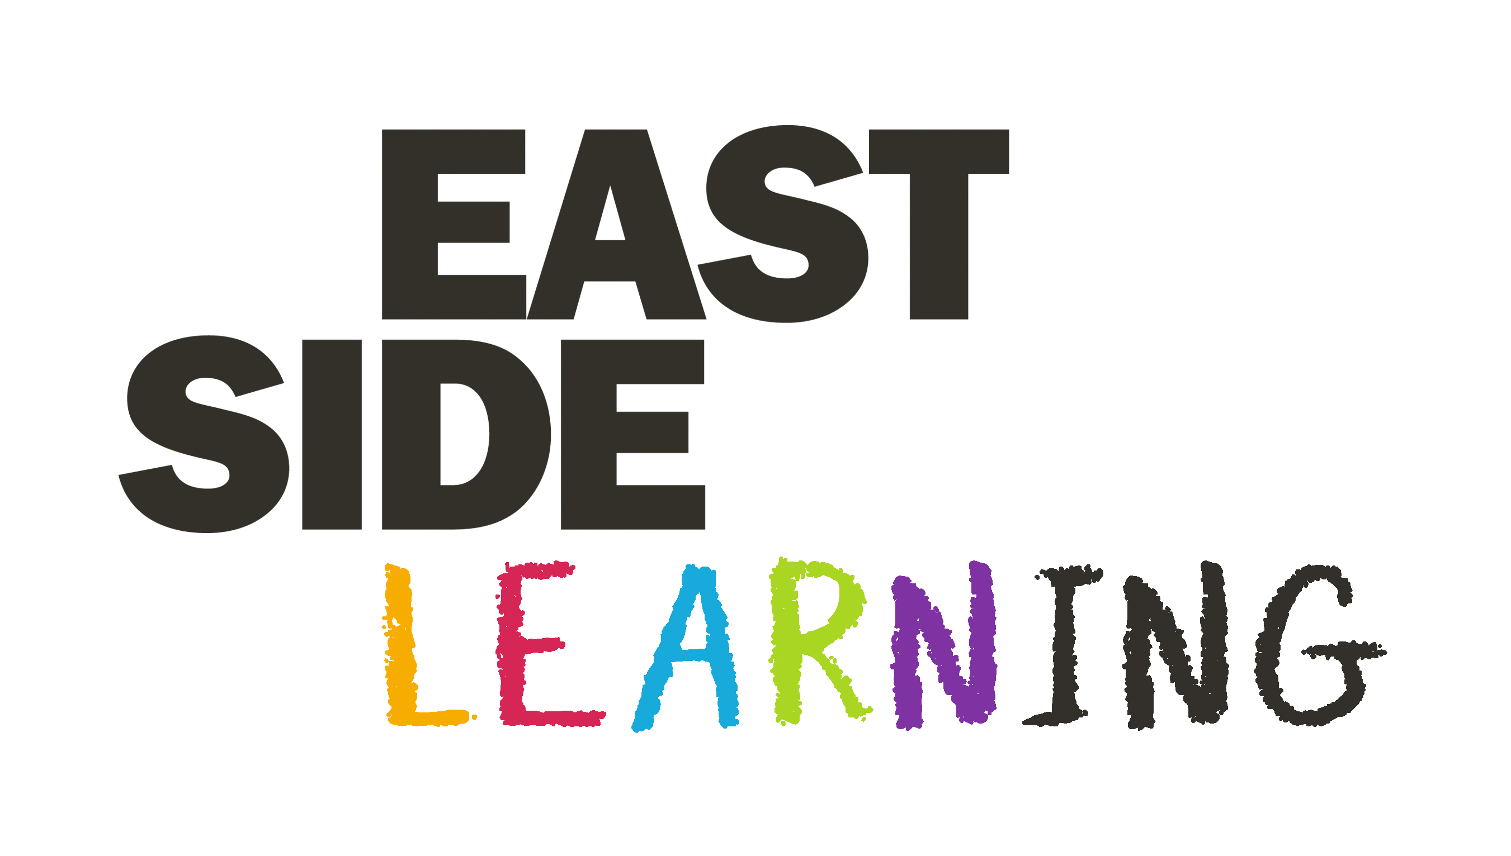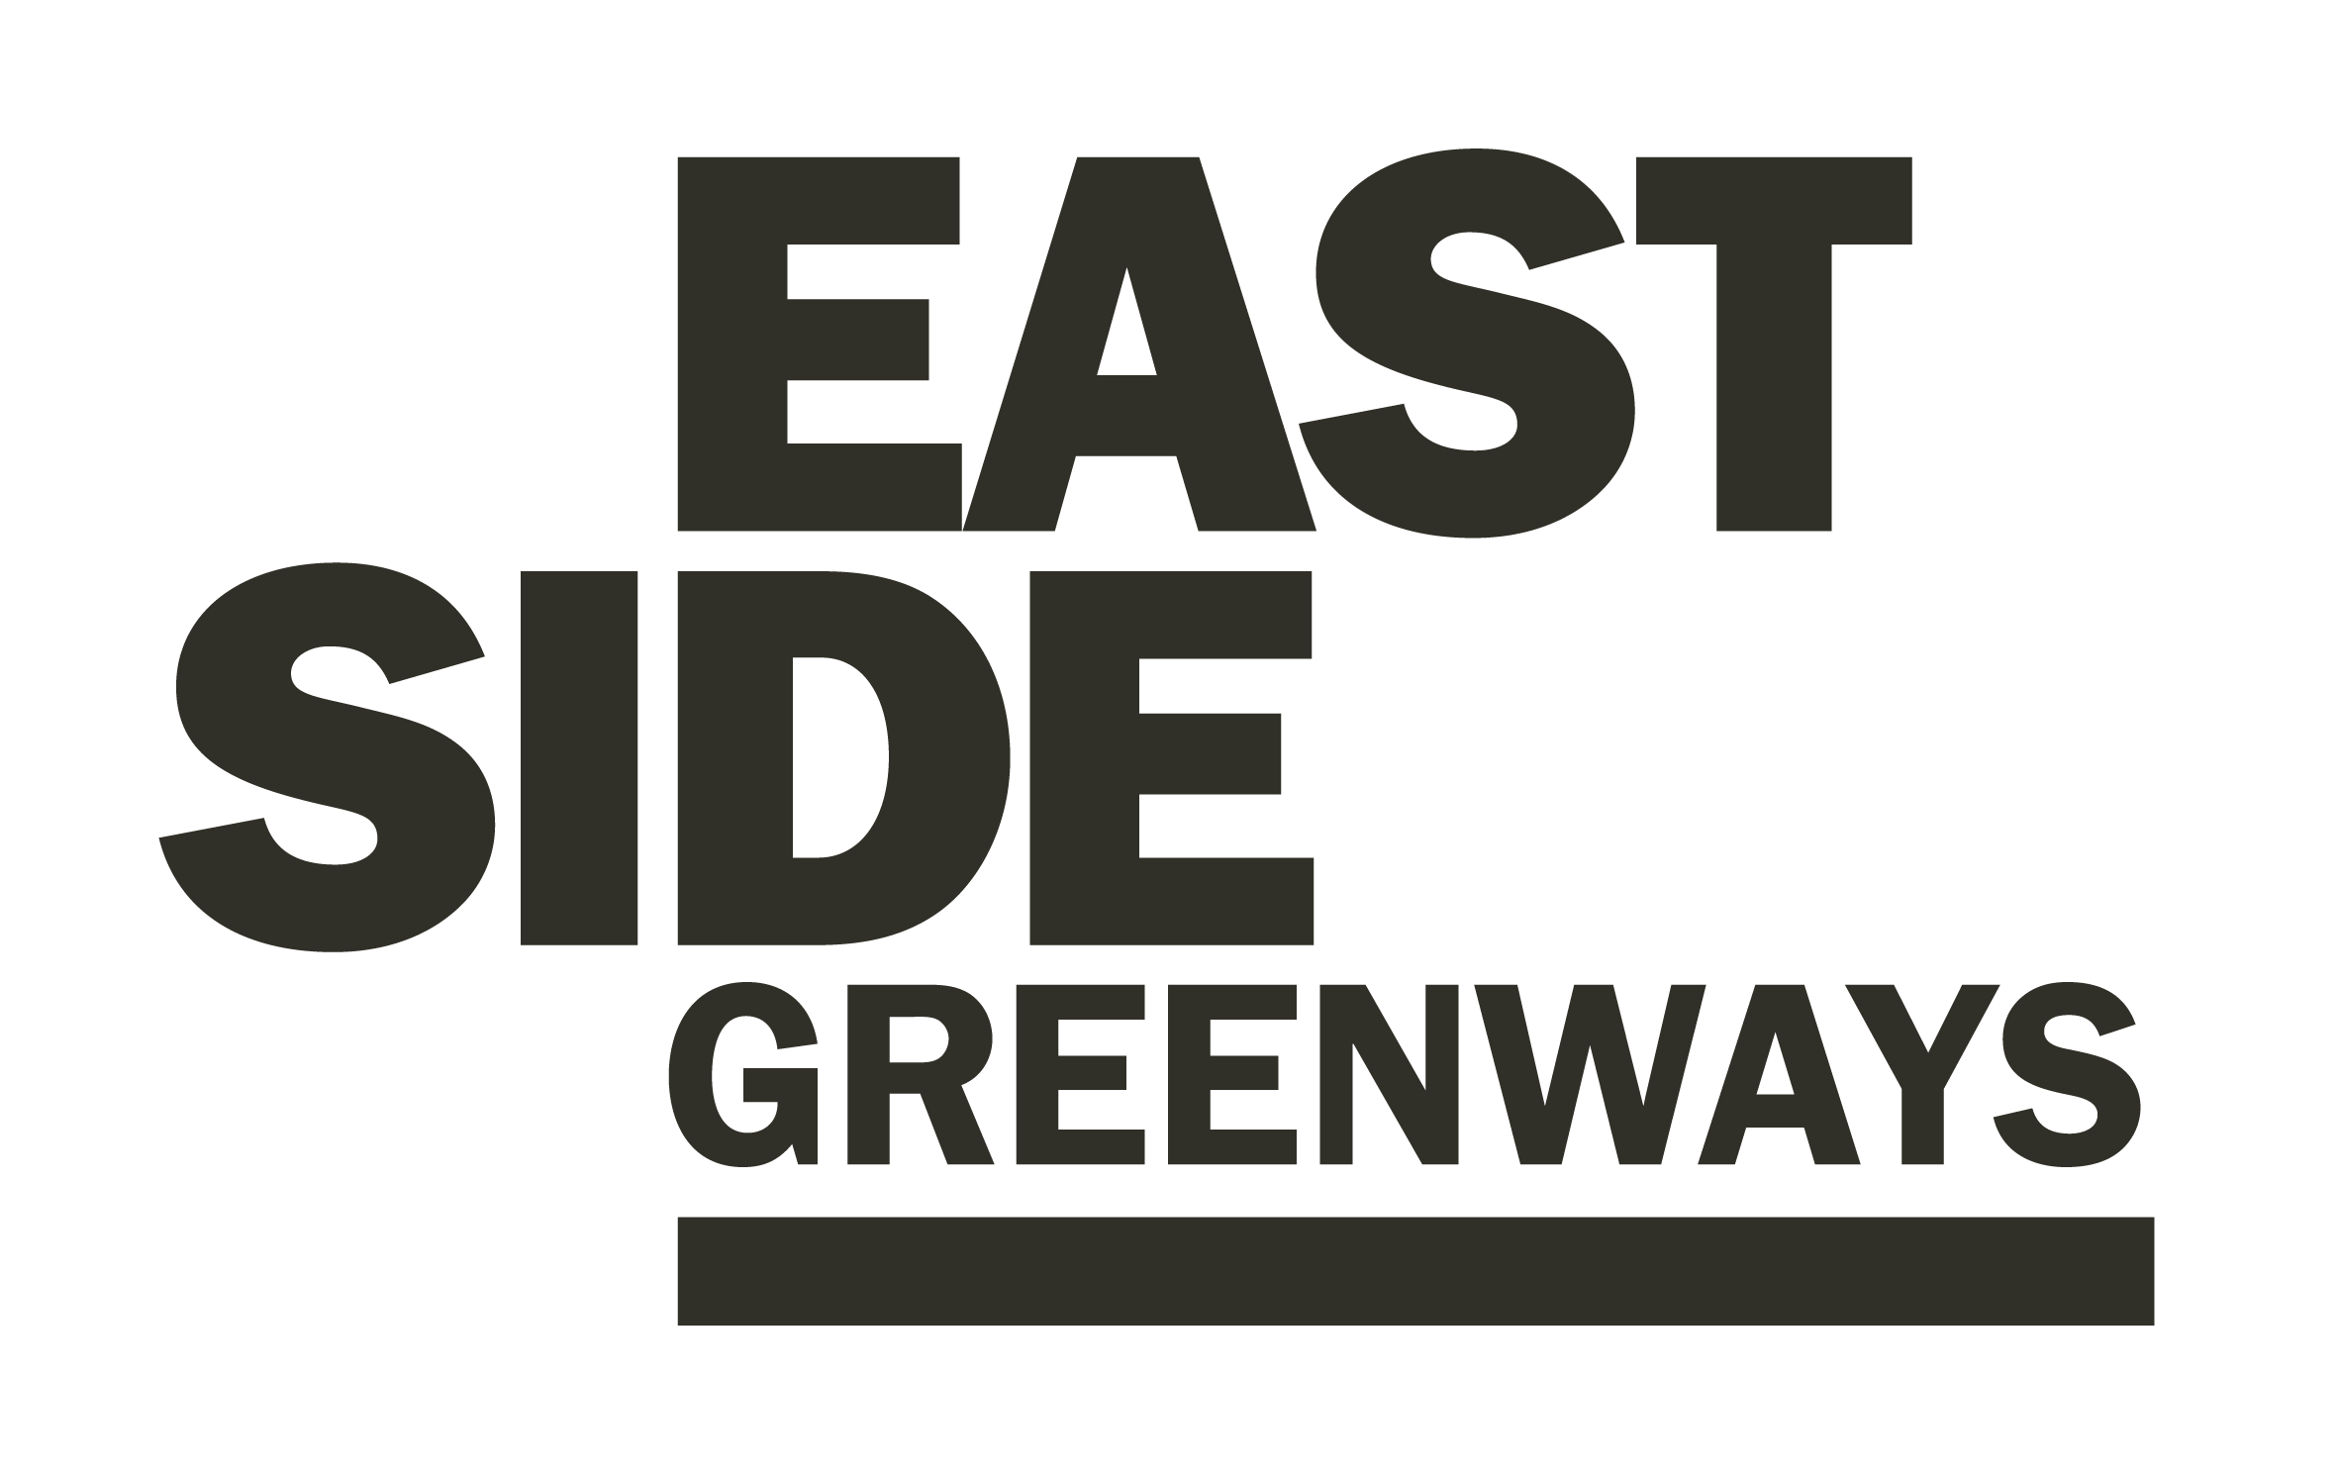
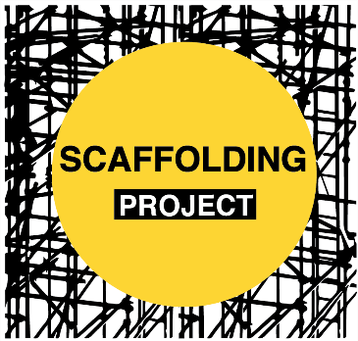

At EastSide Arts our mission is to make Belfast a better place by creating an east Belfast that is a thriving cultural hub; where the arts are valued, creativity is for everyone and people are connected with each other and the wider world.

In 2022/23 we plan to do this by meeting the following objectives:

- To improve equity of opportunity for people in east Belfast to engage with creative activities
- To create a variety of meaningful, open and inclusive opportunities for people in east Belfast to explore creativity and connect with others
- To celebrate the past, present and future of east Belfast;
- To develop relationships that ensure the long-term stability of EastSide Arts and create investment in the arts in east Belfast

More information about our current and past work please visit: www.eastsidearts.net

