Job Description ESP/GL19

Job Title: Greenway Leader

Location: EastSide Partnership, Avalon House, 278-280 Newtownards Road

Reports to: Connswater Community Greenway Trust Manager

Terms and conditions

Positions available: There are currently four posts available

Hours of work: Hours of work vary based on the programmed work and activity along the Connswater Community Greenway. Working hours will be agreed on a weekly basis (approximately 3-10 hours, depending on programme).

Wage: National Minimum Wage/ National Living Wage

EastSide Partnership is only able to accept applications from those individuals who are currently eligible to work in the UK. We will only interview those applicants who appear, from the information provided, to be the most suitable in terms of the person specification.

Main Purpose of Job
The main purpose of the job is to support the positive use of the Connswater Community Greenway, as a well-used, vibrant and dynamic space of outstanding quality for everyone to enjoy.

Greenway Leaders will:

- Support large park events
- Support activities and programme work
- Assist with tours, guides and visits
- Carry out ‘face to face’ engagement on the Greenway
- Carry out low-level management and maintenance

Summary of responsibilities and personal duties

- To provide a high standard of customer service to all users of the Greenway and associated facilities.

- To engage with the general public on a face-to-face basis.

- To provide a visible presence on the Greenway, both on foot and bicycle, building relationships with and between users, connecting people and places.

- To ensure good relations with all user groups including members of the public and respond to requests, provide guidance and deal with or refer any complaints in relation to the site, encouraging positive use of the Greenway, parks and open spaces.

- To have the ‘Greenway Knowledge’ and be able to answer questions and/ or guide groups.

- To assist and support Greenway campaigns, events and activities.

- To greet, signpost and assist users, taking on board or forwarding ideas and suggestions were practical.

- To maintain the orderly condition of the Greenway, free from litter/rubbish and generally tidy, in line with Green Flag standards.

- To monitor the Greenway as an attractive and safe place for users and report any incidents where quality standards are not met.

- To oversee the general safety and behaviour of the public and direct the activities of users to prevent misuse, damage to facilities and equipment and comply with all Health and Safety at Work legislation.

- To support orderly conduct by the public and prevent misuse and nuisance to other users.

- To gather information, monitor use and complete records as required.

- To support and work alongside EastSide Partnership volunteers.

- To undertake general and specific labouring duties as directed, for example, dismantling, maintenance and storage of equipment and materials and use powered hand tools and light plant if required.

- To load, unload and move equipment and materials, such as event stands, gazebos, promotional material such as banners, tables and chairs and horticultural tools.

- To assist in the development of Greenway activities and carry out any agreed duties as required with little or no supervision.

- To identify risks in the course of duty and take the necessary remedial action.

- To assist in the supervision of school, group or community visits.

- Support visits from special interest groups e.g. wildlife groups, walkers, cycle groups, tour groups.

- To assist with social and digital media to promote activities and ongoing use.

- To ensure close liaison with the community, police, emergency services and internal Belfast City Council services as required using radios/mobile phones.

- To ensure all work is carried out in accordance with Health and Safety at Work legislation and council regulations, including the wearing of appropriate uniform, clothing and PPE as required. To administratively assist with first aid, recording accident or incident details, filling out accident or incident reports, recording accidents and reporting all incidents to management through appropriate channels.

- To assist in on-the-job coaching and training, for example, new leaders, work placements and volunteers etc.

- To undertake the duties of the post in such a way as to enhance and protect the reputation and profile of the Greenway.

- To undertake any other duties as may be required from time to time.

Person Specification ESP/GL19

Qualifications and experience

Applicants must, as at the closing date for receipt of application forms:

- be able to demonstrate on the application form, by providing personal and specific examples, 6 months’ work experience of dealing with members of the public in a face-to-face environment
- be able to demonstrate on the application form, by providing personal and specific examples of ability to work as part of a team to maintain excellent working relationships.

*Please note: it will be a condition of any appointment that the successful applicants undergo the Greenway Leader Training Programme (see page 5). Applicants will be required to attain the mandatory skills required for the roles they will undertake. Support and training will be provided. On satisfactory completion of the mandatory skills, applicants will be employed Greenway Leaders.

Special skills and attributes

Applicants must possess the following special skills and attributes, which will be tested at interview:

- good inter-personal skills with an awareness of the importance of customer care;
- the ability to communicate effectively with a range of people/ stakeholders including; members of the public, EastSide Partnership structure Belfast City Council staff, politicians, volunteers and visitors as required;
- enthusiastic and confident, able to gain the support and cooperation of others
- welcoming, approachable and helpful;
- the ability to make decisions about individual working at a basic level;
- the ability to work with others as part of a team;
- a basic understanding of the health and safety responsibilities attached to the post to ensure the safety of members of the public; and
- good basic handwriting and comprehension skills with the ability to complete standard forms clearly.

Circumstances
- Ability and willingness to work flexible hours including evenings and weekend

Disposition
- Well presented & inspires confidence
- Self-motivated and able to work on own initiative

Knowledge and Values
- Commitment to regeneration and a partnership approach
- Knowledge of EastSide Partnership and subsidiary companies

The Greenway Leader Training Programme

Greenway Leaders will be expected to undergo mandatory training and may also have the opportunity to specialise in an area(s) of interest where suitable / required.

DESCRIPTION | Mandatory | Optional
Health and Safety | X
Water Safety |  | X
First Aid | X
CPR |  | X
Access NI | X
Child Protection | X
Vulnerable Adults | X
Lone working | X
Plant and species identification |  | X
Bird spotting |  | X
Water quality testing |  | X
Greenway Knowledge | X
EastSide general knowledge | X
BCC By Laws | X
Rivers and tides |  | X
Tour guiding |  | X
Walk leader Training |  | X
Manual Handling | X
Dealing with difficult people / Leadership / Customer care / Welcome Host | X
Cycling |  | X
Digital Media |  | X
Other

Application Process ESP/GL19

Application

- Completed Application form and Equal Opportunity Monitoring Form should be sent by email to shona@eastsidepartnership.com and will be acknowledged by email. If not acknowledged please contact Shona on 028 9045 1900

- Completed Application form and Equal Opportunity Monitoring Form should be returned by 3.00pm on Friday 8th March.

- EastSide Partnership is only able to accept applications from those individuals who are currently eligible to work in the UK

- We may only interview those applicants who appear, from the information provided, to be the most suitable in terms of the person specification provided.

Equal Opportunities

- EastSide Partnership is an equal opportunities employer. EastSide Partnership does not permit unlawful discrimination of any kind against any person on grounds which include gender, sexual orientation, marital status, religious belief or political opinion, race or disability. Unlawful discrimination is defined as treating a person less favourably than others are, or would be treated in the same or similar circumstances.

Canvassing

- Canvassing in any form will, if proved to the satisfaction of EastSide Partnership, disqualify a candidate for the appointment

Interviews

- Interviews will be held on Thursday 14th March 2019. Please ensure your availability for interview on this date prior to application, as it will not be possible to arrange an alternative date

Job Description

- The duties outlined in the Job Description serve as a guide to the current and major responsibilities of the post. These will inevitably vary as the role develops and the Job Description will be reviewed on a regular basis. Changes will be subject to consultation with the post holder.

Background Information

EastSide Partnership is a regeneration charity which delivers a wide variety of projects with a clear mission, ‘to make east Belfast a better place’ for residents and visitors. We work with local councils, statutory agencies, community organisations, elected representatives and businesses to make east Belfast a great place to live, work, visit, invest and be proud of.

Our vision is that east Belfast will be a great place where:
- Residents enjoy good health and well being
- Education is valued and high standards achieved
- Tourism, arts and hospitality are thriving

EastSide Partnership aims to:
- Contribute to physical regeneration in east Belfast by developing key properties through Landmark East
- Ensure the Connswater Community Greenway is developed and maintained as a destination for all and deliver similar initiatives
- Deliver EastSide Arts festivals, community arts projects and support local arts groups
- Help schools and communities work together to deliver better opportunities for children through EastSide Learning
- Develop the tourism and heritage product to encourage more visitors through EastSide Tourism

EastSide Partnership also provides administrative support for two Neighbourhood Partnerships in east Belfast, Inner East and Tullycarnet and co-ordination support for the Scaffolding Project.

To find out more about EastSide Partnership visit:
- Website- www.eastsidepartnership.com
- Twitter- @EastSidePship
- Facebook- facebook.com/EastSidePship
- Instagram- EastSidePship

The Connswater Community Greenway (CCG) is a 9km linear park through east Belfast, following the course of the Connswater, Knock and Loop Rivers, connecting the open and green spaces and remediating the Connswater River itself. The Greenway reconnects the communities of east Belfast and restores the rivers as community assets. It has created vibrant, attractive, safe and accessible parkland for leisure, recreation and community events and activities.

Connswater Community Greenway improves the living environment, reinstating a valuable amenity for local people and provides opportunities for improving health and well-being. The CCG acts as a catalyst for physical and economic development and improves access and connections for local communities.

The vision for the Connswater Community Greenway is;

‘An inspirational living landmark that is well used, vibrant, dynamic and sustainable. An attractive destination of outstanding quality for everyone to enjoy.’

C.S. Lewis Square

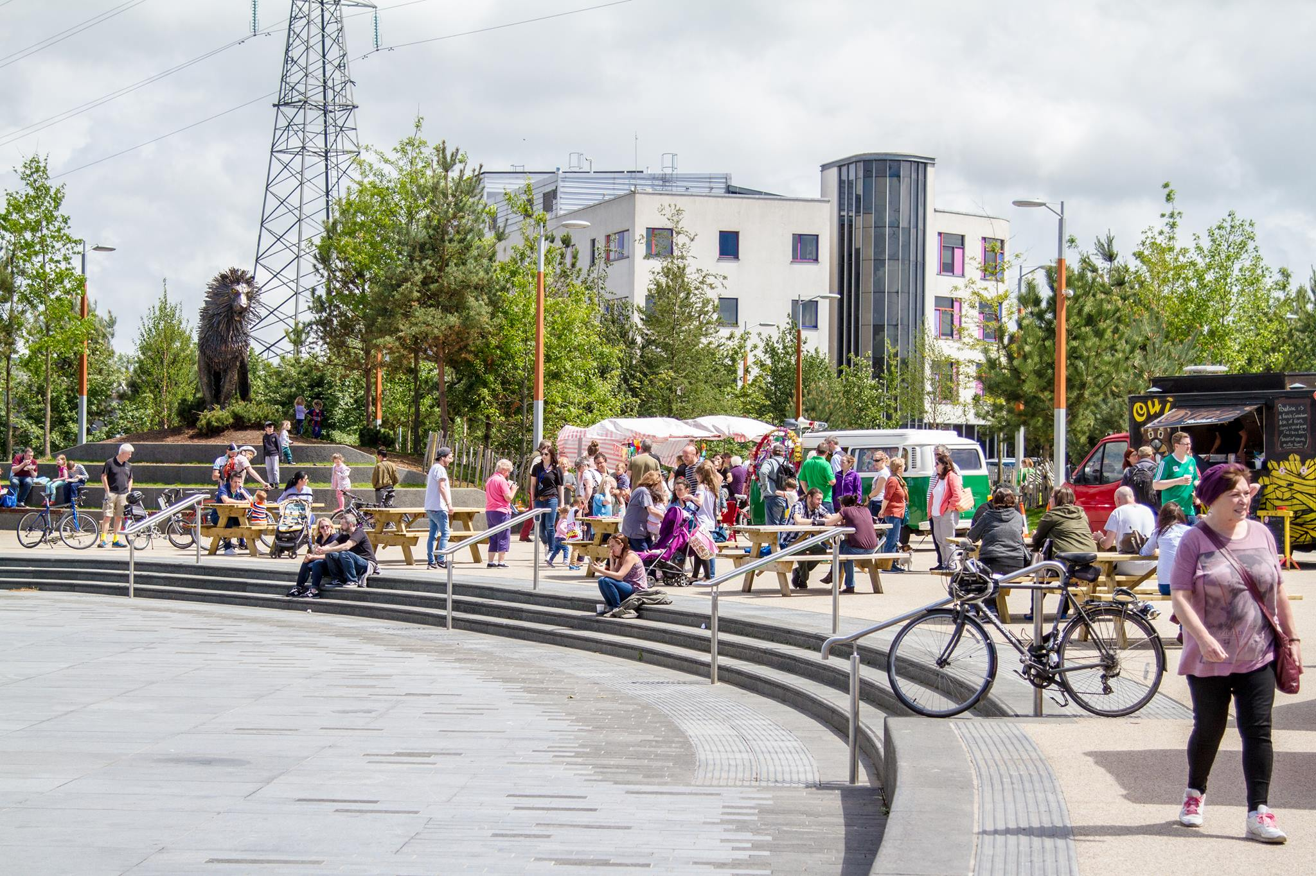
Green Living Market at C.S. Lewis Square Aslan, C.S. Lewis Square

Completed in November 2016, the C.S. Lewis Square is one of the most exciting new event spaces in Belfast, at the heart of the Connswater Community Greenway. Adjacent to the Square is the EastSide Visitor Centre, an innovative building which contains visitor information, a coffee shop and a gallery/ meeting space.

The C.S. Square features over native 300 trees and seven statues inspired by The Lion, the Witch and the Wardrobe by Irish artist Maurice Harron. This fantastic open space regularly hosts community events, markets, music, fitness classes and much more.

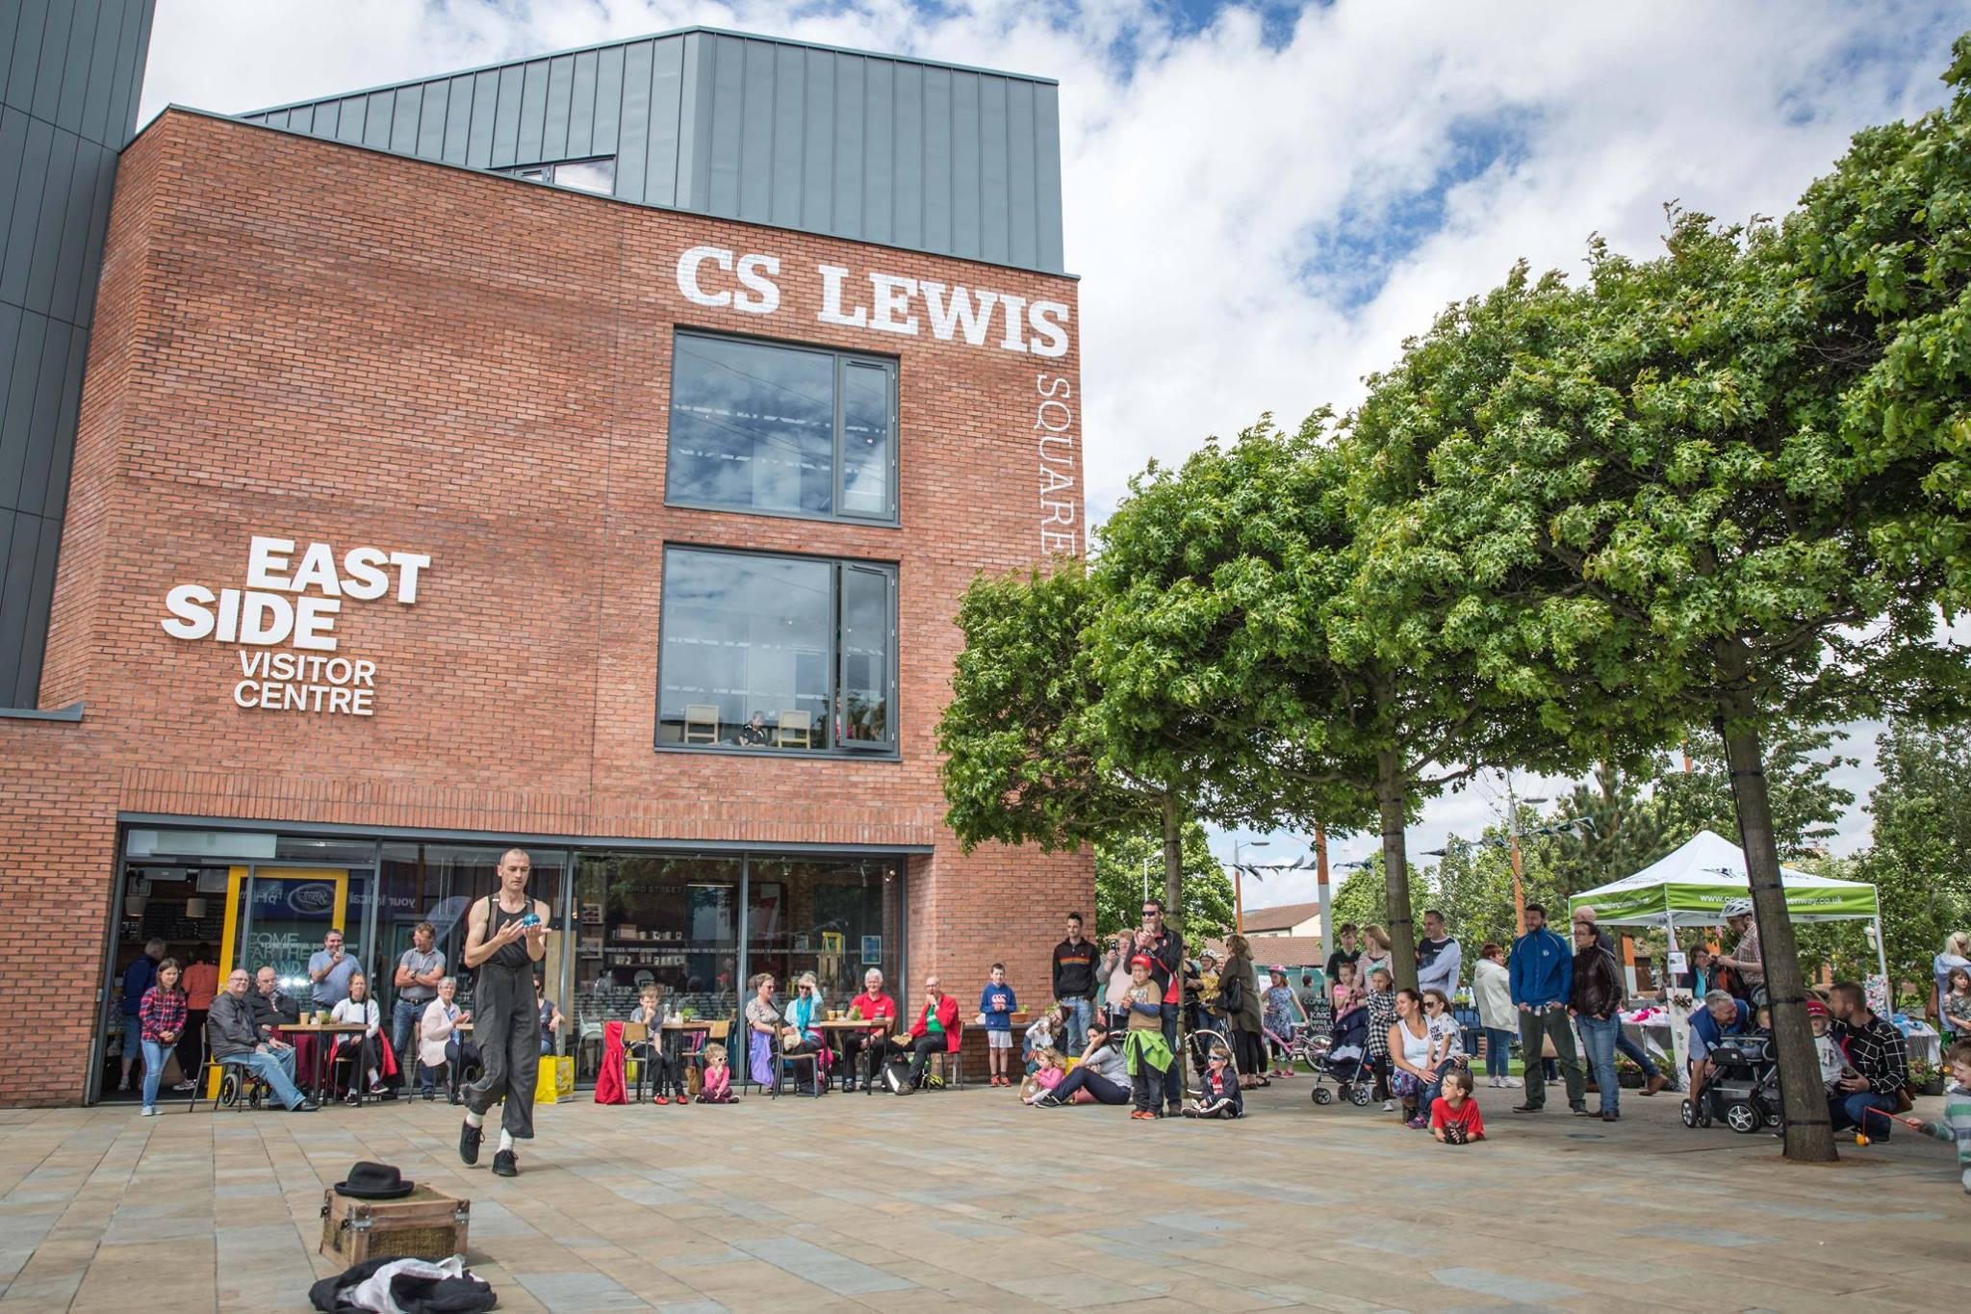
EastSide Visitor Centre at C.S. Lewis Square

To find out more visit:
- Twitter- @ConnsGreenway
- Facebook- facebook.com/ConnswaterCommunityGreenway
- Instagram- connswater_greenway

