Job Description ESP/ESLM23

Project: EastSide Learning

Job Title: EastSide Learning Manager

Location: EastSide Partnership offices at Avalon House (Newtownards Road, Belfast) and the Carew Centre (Tamar Street, Belfast).

Reports to: Chief Executive, EastSide Partnership

Terms and conditions

Salary: NJC Point 32-43, currently £38,296 to £49,590 + 7.5% pension.

Contract: This is a permanent post, however will be dependent on future funding. Job subject to 6 month probation period.

Work hours: 37.5 hours per week but willingness to work flexible hours including evenings and weekends essential.

Holidays: 25 days per year plus statutory holidays.

EastSide Partnership is only able to accept applications from those individuals who are currently eligible to work in the UK. We may only interview those applicants who appear, from the information provided, to be the most suitable in terms of the person specification.

Main Purpose of Job
The main purpose of the role is:

- To support the EastSide Learning (ESL) Board in delivering its key strategic objectives, through the provision of strong leadership and an ambitious and confident vision for improving outcomes for children and families in east Belfast.

- To work with key stakeholders, lead the ESL team, manage the programme and secure the necessary resources and partnerships needed to deliver the objectives.

Summary of responsibilities and personal duties

- To deliver the EastSide Learning strategic framework, including the development of existing and new education focussed initiatives across east Belfast, to raise aspiration, support parents, improve outcomes and remove barriers for children experiencing disadvantage.
- To play a leading role in enabling EastSide Learning to develop its strategic thinking, planning, and positioning for the years ahead.
- To provide leadership and strategic direction that secures new funding to address key issues and maximises the efficient use of available resources.
- To be a voice for and represent the interests of education stakeholders in east Belfast on relevant forums addressing educational disadvantage.
- To establish a strong profile for EastSide Learning as the lead independent voice for education in east Belfast; connecting communities and schools to provide strategic support and co-ordination.
- To lead and support integrated planning, improving communication, collaboration, and partnership working to deliver a shared vision for education in east Belfast.
- To oversee the development, growth and long term sustainability of the Carew Family Centre as a hub for collaborative services to improve outcomes for children and families.
- To manage resources, contracts, and key partnerships essential to the delivery of the vision of Carew Family Centre, aligned to the Early Learning Community Strategy.
- To oversee all operational aspects of the day to day management of Carew Family Centre as a facility for children and families.
- To work with the Chairperson and Board to provide effective leadership and to ensure the Board is fit for purpose.
- To lead and manage EastSide Learning staff members ensuring their professional performance and development needs are monitored and addressed through appraisal and that the culture of a learning organisation delivering high quality services permeates throughout the team.
- To ensure that all funder requirements and expectations are met.
- To ensure that sound financial management and corporate governance systems and processes are in place to enable Board objectives and financial duties to be met.
- To advise the Board on all strategic issues, and to ensure that the Board is kept fully informed of performance issues and potential risks.
- To ensure that all EastSide Learning delivered programmes, events and activities comply with relevant legislation, health and safety requirements and current best practice.
- To contribute to the overall strategic management of EastSide Partnership through the management team.
- To work collaboratively with EastSide Partnership colleagues to fulfil mutual objectives and deliver shared programmes where appropriate.
- To provide support to, develop and deliver complementary programmes that will support the aims and objectives of EastSide Learning.
- To act in accordance with EastSide Partnership and EastSide Learning’s policies and procedures.
- To undertake such other relevant duties as may from time to time be required.

Person Specification ESP/ESLM23

 | Essential | Desirable
Experience | A minimum of 6 months’ experience gained in the last 5 years in the following:  - Experience of a community development approach to programmes or related practices.  - Experience of managing budgets.  Experience of leading partnerships and consortia at a local or regional level.  Experience of people and stakeholder management, including staff, consultants and organisations operating in a related field.  Experience of developing funding proposals, including securing engagement of consortium partners as needed. | Broad knowledge of education issues relevant to east Belfast.  Experience of working with vulnerable adults and children.  Experience of centre management offering a range of services.
Attainments/ Education | A relevant third level qualification (e.g. Project management, Community Development, Education) | A relevant management qualification  A recognised training qualification
Skills & abilities | Ability to lead and motivate team(s) - co-ordinating, motivating and leading staff, volunteers and / or community groups.  Ability to anticipate and identify issues and potential risks and take a proactive approach to resolving them.  Ability to prepare, monitor and review budgets and work plans.  Excellent communication skills (including writing skills) and the ability to produce reports and other materials for a wide range of stakeholders, to a high standard.  An understanding and knowledge of place -based funding and regeneration; community development approaches. | Experience of developing programmes focussed on learning in partnership with schools.  An awareness of the needs of schools, parents and other relevant stakeholders.  Gathering and analysing information and evidence relevant to improving outcomes for children in east Belfast.
Disposition | Energetic, enthusiastic and inspires confidence.  Able to deal with multiple projects and determine priorities.  A team leader open to learning and supporting others.  Works with autonomy and uses own initiative.  Able to rely upon own judgement and knows when to seek further assistance.
Knowledge & Values | Knowledge of issues relevant to EastSide Learning.  Knowledge of EastSide Partnership.  Commitment to regeneration and a partnership approach.  Committed to equality and diversity.
Circumstances | Willingness to work flexible hours including evenings and weekends.

Application Process ESP/ESLM23

Application

- An application pack can be downloaded from: www.eastsidepartnership.com/recruitment

- Completed applications must arrive by 12pm on Wednesday 31st May 2023.

- Applications will only be accepted by email to: gillian@eastsidepartnership.com and will be acknowledged by email.

- Application MUST be by letter outlining how you meet all of the criteria in the person specification. The letter must be no longer than 2 x A4 pages, minimum font size 10. We suggest you use all the headings in the person specification to ensure that you address the criteria. You may also include a CV (max 2 x A4 pages, minimum font size 10) but please ensure that if you enclose a CV, you cover how you meet all criteria, as detailed in the person specification, in your letter.

- Only information contained in the letter and accompanying CV will be taken into account, so please ensure that you include all relevant information. Any content exceeding the 2 x A4 limit will be disregarded.

- To be accepted the application must include the monitoring form.

- Access requirements: Please let us know about any reasonable adjustments you may require during the recruitment process, including the application stage.

- We may only interview those applicants who appear, from the information provided, to be the most suitable in terms of the person specification provided.

Equal Opportunities
- EastSide Partnership is an equal opportunities employer. EastSide Partnership does not permit unlawful discrimination of any kind against any person on grounds which include gender, sexual orientation, marital status, religious belief or political opinion, race or disability. Unlawful discrimination is defined as treating a person less favourably than others are, or would be treated in the same or similar circumstances.

Canvassing
- Canvassing in any form will, if proved to the satisfaction of EastSide Partnership, disqualify a candidate for the appointment

Shortlisting
- Shortlisting is due to take place on Thursday 1st June 2023 after which you will be informed by email whether or not you are to be called for interview, and at what time. The panel may decide to only interview those candidates who best meet the essential criteria.

Interviews
- Interviews will be held on Thursday 8th June 2023. Please ensure your availability for interview on this date prior to application, as it will not be possible to arrange an alternative date.

Job Description
- The duties outlined in the Job Description serve as a guide to the current and major responsibilities of the post. These will inevitably vary as the role develops and the Job Description will be reviewed on a regular basis. Changes will be subject to consultation with the post holder.

Further Information
- Further information on EastSide Partnership can be viewed on our website at: www.eastsidepartnership.com

For office use only
App Ref:

Equal Opportunities Monitoring Form ESP/ESLM23

Private & Confidential

We are an Equal Opportunity Employer. We do not discriminate on grounds of religious belief or political opinion. We practice equality of opportunity in employment and select the best person for the job.

To demonstrate our commitment to equality of opportunity in employment we need to monitor the community background of our applicants and employees, as required by the Fair Employment and Treatment (NI) Order 1998.

Regardless of whether we practice religion, most of us in Northern Ireland are seen as Catholic or Protestant. We are therefore asking you to please indicate your community background by ticking the appropriate box below.

I am a member of the Protestant community

I am a member of the Roman Catholic community

I am a member of neither the Protestant nor Roman
Catholic community

Please indicate whether you are: Female

Male

If you do not complete this questionnaire, we are encouraged to use the “residuary” method, which means that we can make a determination on the basis of personal information on file/application form.

Note: It is a criminal offence under the legislation for a person to “give false information in connection with the preparation of the monitoring return”.

Background Information

EastSide Partnership is a local charity leading the regeneration of east Belfast. Working alongside other community-based organisations, elected representatives, statutory agencies and local businesses, EastSide Partnership delivers a wide variety of projects with a clear mission to ‘make east Belfast a better place’ for residents, businesses and visitors.

EastSide Partnership aims to:
- Create an east Belfast that is a thriving cultural hub, where the arts are valued, creativity is for everyone and people are connected with each other and the wider world through EastSide Arts
- Promote the use and development of green open spaces, parks, rivers and off-road transport routes in east Belfast through EastSide Greenways including Connswater Community Greenway
- Help and support children in east Belfast to develop their abilities, reach their potential and experience success, whatever their background through EastSide Learning
- Contribute to the regeneration of east Belfast through the strategic acquisition, development and management of sites and properties through EastSide Property
- Coordinate and deliver responsible, sustainable and impactful culture-led regeneration, pushing boundaries to put east Belfast on the map through EastSide Tourism
- Raise awareness and help alleviate the impact of poverty in inner east Belfast through the Scaffolding Project

To find out more about EastSide Partnership visit:
- Website- www.eastsidepartnership.com
- Twitter- @EastSidePship
- Facebook- facebook.com/EastSidePship
- Instagram- EastSidePship

Additional Information

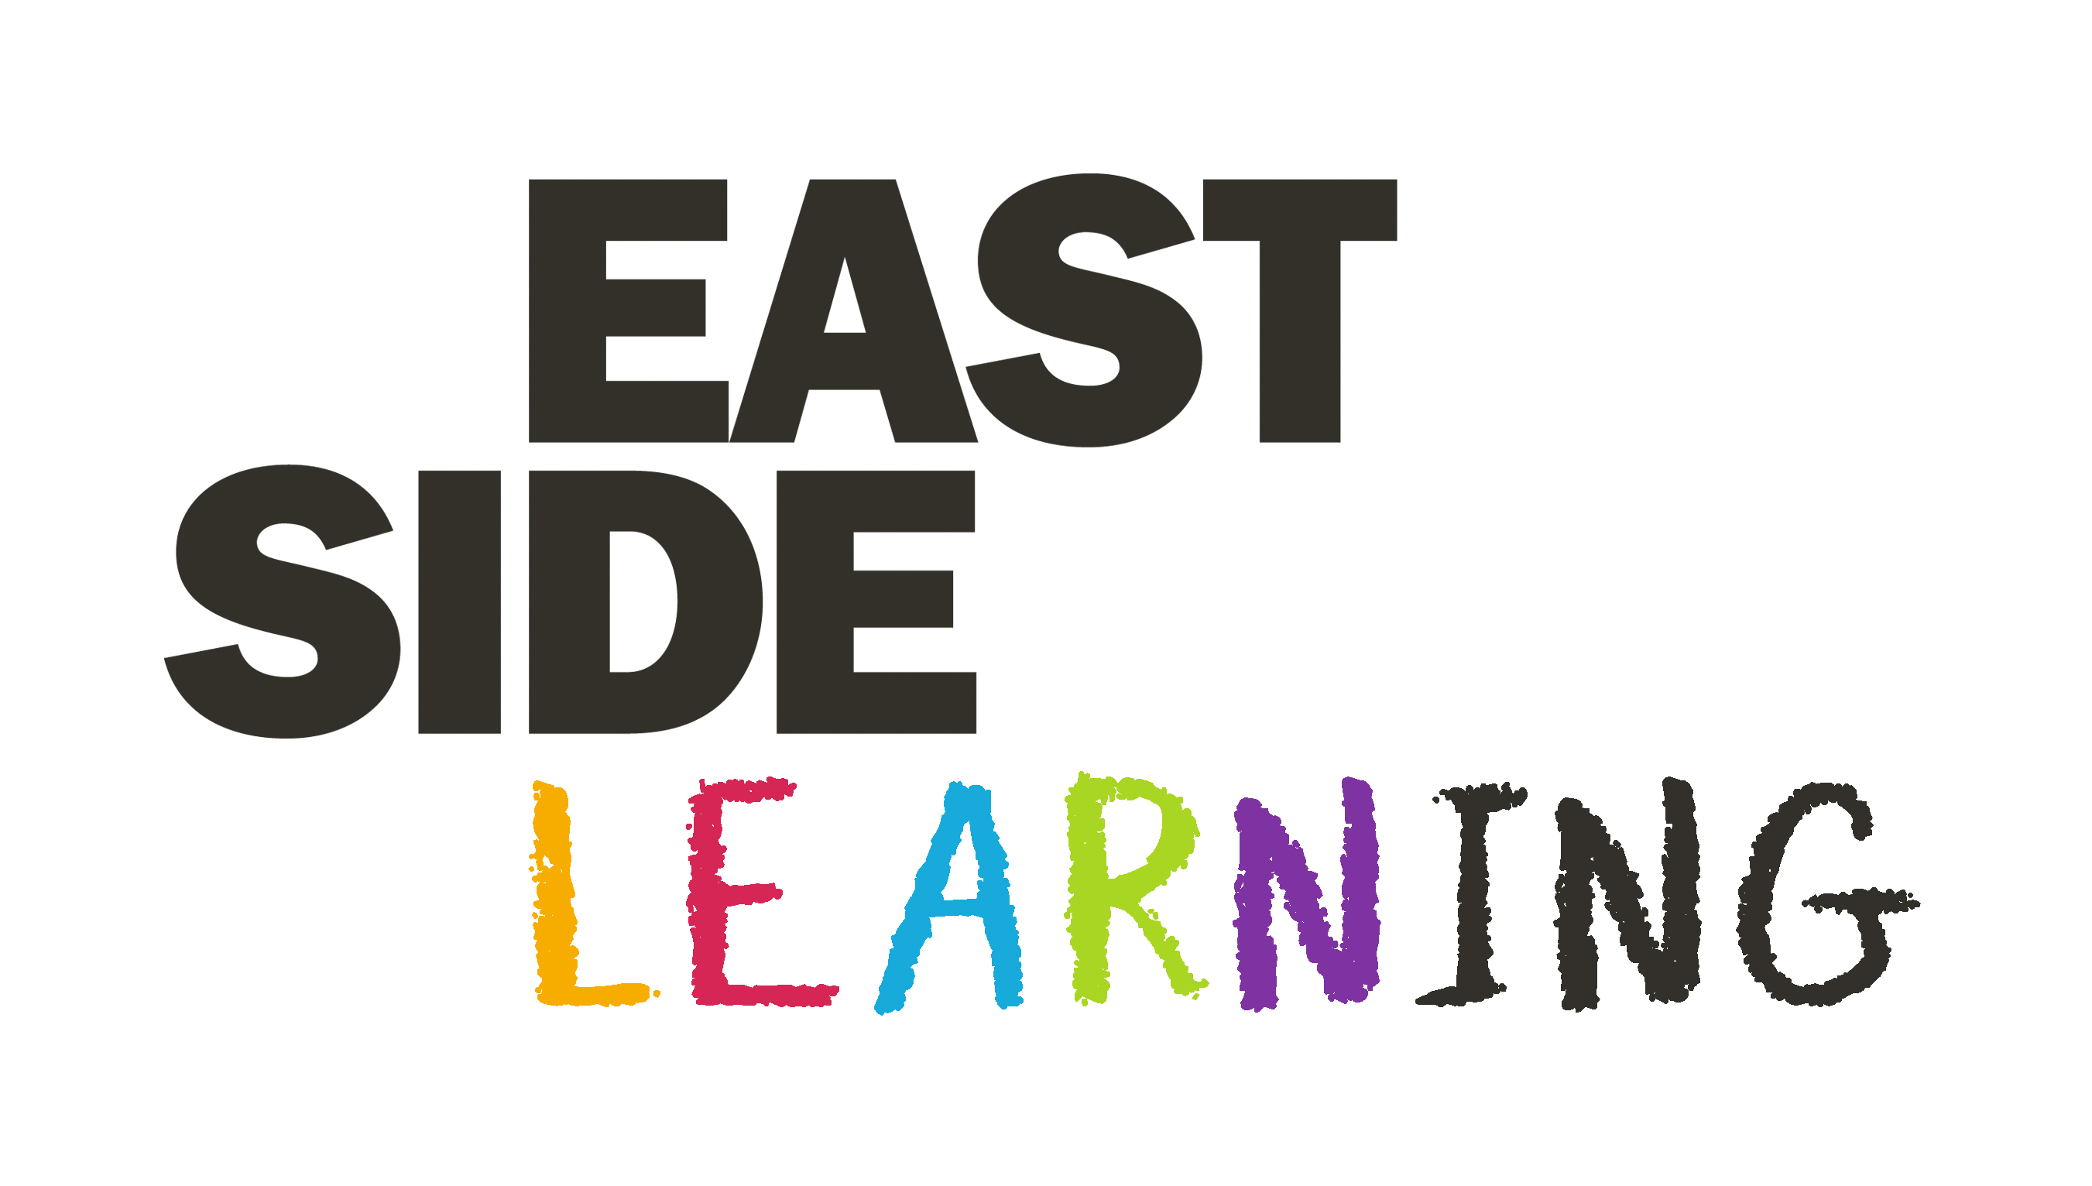
EastSide Learning’s overall aim is to help and support children in east Belfast to develop their abilities, reach their potential and experience success; whatever their background.

To fulfil the aim EastSide learning will:

1. Build aspiration and improve achievement
ESL will provide activities that will support parents to become more confident and involved in their children’s learning, offer training and advice, and broker improved relationships with schools; all contributing to developing a positive community ethos that values education and improves performance.

2. Develop Early Years
ESL is committed to securing more investment in early years settings and primary schools. We will continue to support and build the EastSide Early Years Network and the EastSide Early Learning Community to improve links across phases, share good practice and improve training for all early year’s staff.

3. Support Smoother Transitions
We will have an intentional focus on supporting smoother transitions throughout the system from early years to leaving school; underpinning all our interventions to focus on confidence building and social and emotional wellbeing to ensure readiness to learn at all stages.

4. Value all Educational Pathways and enrich learning
ESL will provide support for the development of new and existing opportunities that broaden the skill set and develop the interests of children and young people in a range of STEM Creative and World Around Us activities.

5. Collaborate, Coordinate and Work in Partnership
ESL will bring all the key organisations together to ensure good planning, improve how we communicate with each other and thereby improve the quality and delivery of services.

