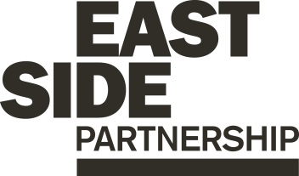

Job Description ESP/ESGCPO19

Project: EastSide Greenways

Job Title: Community Project Officer

Location: EastSide Partnership, Avalon House

Reports to: EastSide Greenways Manager

Terms and conditions

Salary: Starting on NJC Point 19, on a scale of points 19–25, currently £24,799 - £28,785, + 7.5% pension

Contract: This is a permanent post. Job subject to 6 month probation period with a full role review after 2 years.

Holidays: 25 days per year plus statutory holidays.

Hours of work: 37.5 hours per week but willingness to work flexible hours including evenings and weekends is essential.

The following gives an indication of the current main duties and responsibilities of the post. The post holder will be expected to work flexibly and carry out any other duties appropriate to the role which may reasonably be required from time to time.

Main Purpose of Job

The main purpose of this role is to:

- Support the EastSide Greenways Manager to deliver the Connswater Community Greenway strategic objectives

- Carry out effective engagement with the community and stakeholders in relation to the Connswater Community Greenway and the potential wider network of EastSide Greenways

- Support the successful delivery of an annual animation programme of exciting, welcoming and fun events and activities which make a positive difference to the east Belfast community

Summary of responsibilities and personal duties

- Assist in the delivery of projects and campaigns to promote and encourage community ownership, youth engagement, environmental consciousness and healthy lifestyles

- Assist in the preparation, delivery and monitoring of an annual animation programme of events and activities for local residents and visitors

- Develop creative and effective ways to work with the ‘Greenway community’ as a beneficial resource for businesses, schools, colleges, residents and community groups

- Support the management of a team of Greenway Leaders and Volunteers to include work schedules, training and development

- Ensure that all delivered programmes comply with relevant legislation, health and safety requirements including risk assessment and current best practice

- Deal with and investigate complaints and queries as they arise providing effective customer service and providing solutions where appropriate

- Represent the project at relevant forums and networks to build relationships with our stakeholders and share relevant information

- Carry out presentations to local stakeholders using excellent communication skills

- Complete funding applications to support the delivery of relevant programmes

- Undertake other duties relevant to the role including:

- Provide day to day project administration and support
- Manage relevant and appropriate resources and equipment
- Work alongside communications staff at EastSide Partnership and Belfast City Council to ensure that all activity is marketed and promoted to maximise participation
- Report against objectives to ensure outcomes are being met and that monitoring and evaluation is undertaken
- Act in accordance with EastSide Partnership’s policies and procedures
- Undertake such other relevant duties as may from time to time be required

Person Specification ESP/ESGCPO19

 | Essential | Desirable
Experience | - A minimum of 2 years’ experience gained in the last 5 years of;  - Managing projects/ events/ activities  - Community development  - Communicating and engaging effectively with a diverse range of people at all levels | - Experience of;  - partnership working  - managing staff and volunteer  - managing budgets  - writing successful funding applications
Attainments/ Education | - A third level qualification | - A management qualification  - A recognised qualification/ training in health and safety and/ or risk management
Skills | - Ability to establish and maintain excellent working relationships and partnerships with a broad range of stakeholders, individuals and organisations  - Ability to be creative, innovative and work on own initiative  - Effective organisation skills with the ability to manage and prioritise workload and meet deadlines  - Excellent interpersonal and communication skills
Disposition | - Well presented & inspires confidence  - Self-motivated and initiative taking  - Passionate, inspiring and dynamic  - Ability to work collaboratively and as part of a team  - Flexible and pragmatic  - Creative and innovative
Knowledge & Values | - Knowledge of Connswater Community Greenway and EastSide Partnership  - Commitment to regeneration and a partnership approach
Circumstances | - Willingness to work flexible hours including evenings and weekends

Equal Opportunities Monitoring Form ESP/ESGCPO19

Ref No: ESP/ESGCPO19 Private & Confidential

We are an Equal Opportunity Employer. We do not discriminate on grounds of religious belief or political opinion. We practice equality of Opportunity in employment and select the best person for the job.

To demonstrate our commitment to equality of opportunity in employment we need to monitor the community background of our applicants and employees, as required by the Fair Employment and Treatment (NI) Order 1998.

Regardless of whether we practice religion, most of us in Northern Ireland are seen as Catholic or Protestant. We are therefore asking you to indicate your community background by ticking the appropriate box below.

I am a member of the Protestant community

I am a member of the Roman Catholic community

I am a member of neither the Protestant nor Roman
Catholic community

Please indicate whether you are: Female

Male

If you do not complete this questionnaire, we are encouraged to use the “residuary” method, which means that we can make a determination on the basis of personal information on file/application form.

Note: It is a criminal offence under the legislation for a person to “give false information in connection with the preparation of the monitoring return”.

Application Process ESP/ESGCPO19

Application
- Completed applications must arrive by 12pm on Wednesday 13th November 2019

- Applications will only be accepted by email to gillian@eastsidepartnership.com and will be acknowledged by email. If not acknowledged please contact Gillian on 028 9046 7902

- Application MUST be by letter outlining how you meet all of the criteria in the person specification. The letter must be no longer than 2 x A4 pages, minimum font size 11. You may also include a CV (max 2 x A4 pages, minimum font size 11) but please ensure that if you enclose a CV, you cover how you meet all criteria as detailed in the person specification, in your letter

- To be accepted the application MUST include the monitoring form

- Only information contained in the letter and accompanying CV will be taken into account, so please ensure that you include all relevant information. Any content exceeding the 2 x A4 limit will be disregarded

- We may only interview those applicants who appear, from the information provided, to be the most suitable in terms of the person specification provided.

Equal Opportunities
- EastSide Partnership is an equal opportunities employer. EastSide Partnership does not permit unlawful discrimination of any kind against any person on grounds which include gender, sexual orientation, marital status, religious belief or political opinion, race or disability. Unlawful discrimination is defined as treating a person less favourably than others are, or would be treated in the same or similar circumstances.

Canvassing
- Canvassing in any form will, if proved to the satisfaction of EastSide Partnership, disqualify a candidate for the appointment

Interviews
- Interviews will be held on Monday 18th November. Please ensure your availability for interview on this date prior to application, as it will not be possible to arrange an alternative date

Job Description
- The duties outlined in the Job Description serve as a guide to the current and major responsibilities of the post. These will inevitably vary as the role develops and the Job Description will be reviewed on a regular basis. Changes will be subject to consultation with the post holder.

Background Information

EastSide Partnership is a regeneration charity which delivers a wide variety of projects with a clear mission, ‘to make east Belfast a better place’ for residents and visitors. We work with local councils, statutory agencies, community organisations, elected representatives and businesses to make east Belfast a great place to live, work, visit, invest in and be proud of.

Our vision is that east Belfast will be a great place where:
- Residents enjoy good health and well being
- Education is valued and high standards achieved
- Tourism, arts and hospitality are thriving

EastSide Partnership aims to:

- Contribute to physical regeneration in east Belfast by developing key properties through EastSide Property
- Ensure the Connswater Community Greenway is developed and maintained as a destination for all and deliver similar initiatives through EastSide Greenways
- Deliver EastSide Arts festivals, community arts project and support local arts groups
- Facilitate schools and communities to work together to deliver better outcomes for children through EastSide Learning
- Increase visitors to east Belfast and ensure that the potential socio-economic benefits of tourism are maximised at a local level through EastSide Tourism
- Develop a strategic approach and facilitate campaigns, activities and events to alleviate the effects of poverty in east Belfast through the Scaffolding Project

For more information please visit www.eastsidepartnership.com
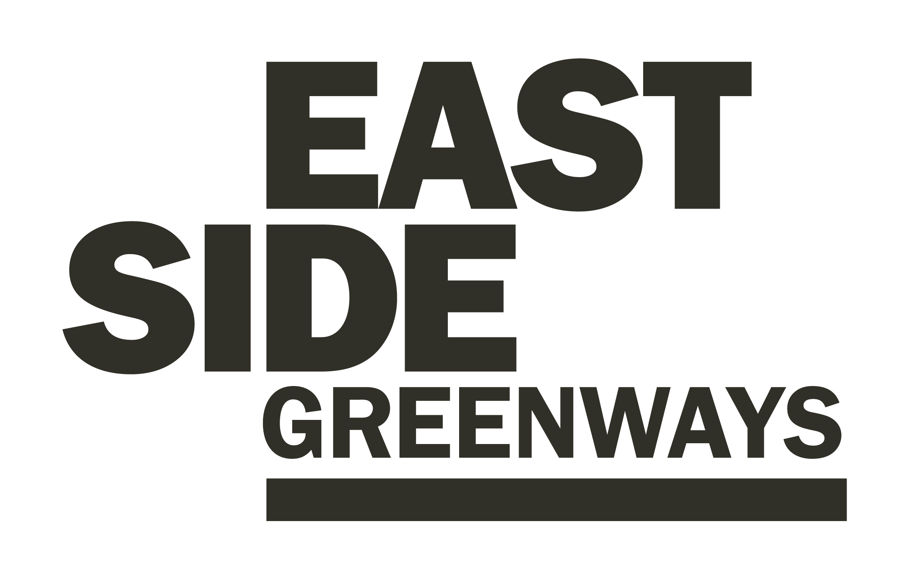
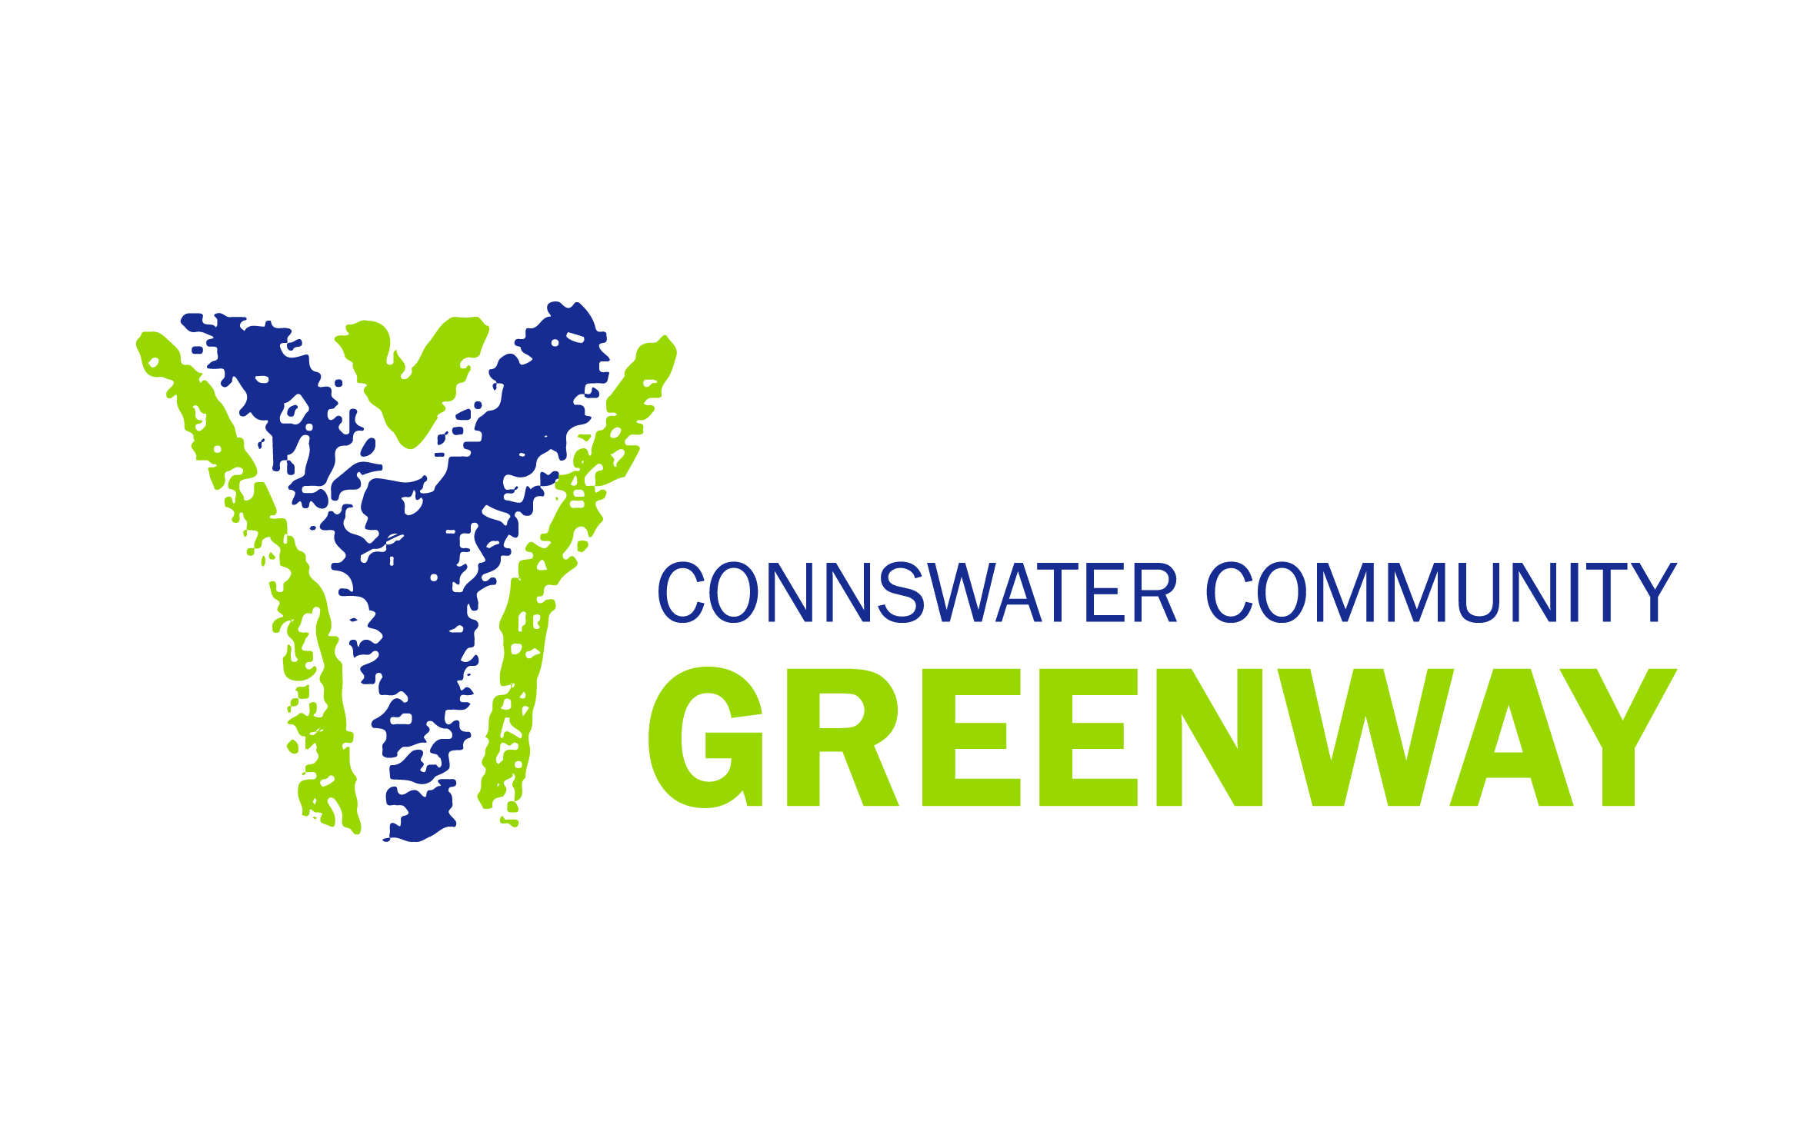

EastSide Greenways was launched in October 2019 to build on the success of the Connswater Community Greenway as well as reflecting the wider scope of work for the organisation.

The EastSide Greenways concept plan has the potential to;
- Identify potential greenway routes in addition to the current Comber and Connswater Community Greenways
- Identify existing links that could be enhanced
- Identify potential new linkages that would enhance accessibility across the network
- Highlight the proximity of the network to existing community facilities and other destinations
- Develop the relationship of communities to the network
- Develop network ‘hubs’ such as C.S. Lewis Square
- Integrate the network with other transport infrastructure
- Encourage linkages with the city centre, Titanic Quarter and other key destinations Integrate the network with wider city and regional cycle and pedestrian network

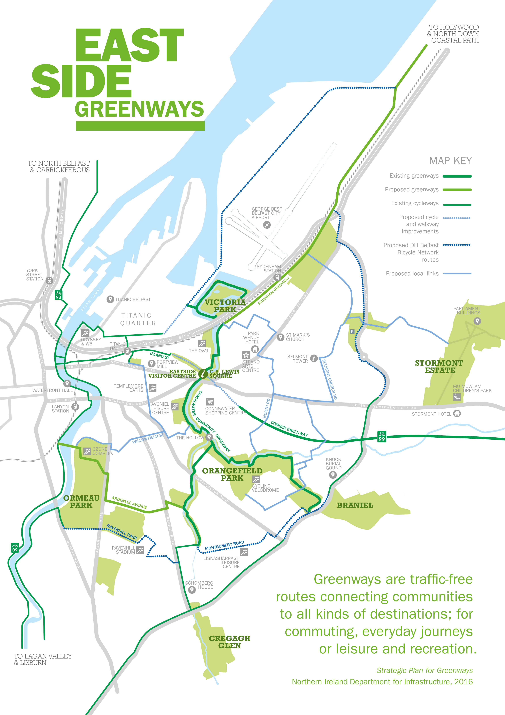

The Connswater Community Greenway (CCG) is a 9km linear park through east Belfast, following the course of the Connswater, Knock and Loop Rivers, connecting the open and green spaces and remediating the Connswater River itself. The Greenway connects the communities of east Belfast and restores the rivers as community assets. It has created vibrant, attractive, safe and accessible parkland for leisure, recreation and community events and activities.

Connswater Community Greenway improves the living environment, reinstating a valuable amenity for local people and provides opportunities for improving health and well-being. The CCG acts as a catalyst for physical and economic development and improves access and connections for local communities.

The vision for the Connswater Community Greenway is;

‘An inspirational living landmark that is well used, vibrant, dynamic and sustainable. An attractive destination of outstanding quality for everyone to enjoy.’

