

Job Description ESP/ESLPO1025

Project: EastSide Learning

Job Title: Project Officer

Location: EastSide Partnership (Avalon House) and Carew Family Centre

Reports to: EastSide Partnership Manager

Terms and conditions

Salary: Annual salary of £32,061, plus 7.5% employer pension contribution. Annual salary increments are agreed by the Board of Directors.

Contract: This is a permanent post, subject to receipt of future funding.

Job subject to 6 month probation period.

Holidays: 25 days per year plus statutory holidays.

Hours of work: 37.5hrs per week but willingness to work flexible hours including evenings and weekends is essential.

The following gives an indication of the current main duties and responsibilities of the post. The post holder will be expected to work flexibly and carry out any other duties appropriate to the role which may reasonably be required from time to time.

Main Purpose of Job
To contribute to the planning, development and delivery of programmes to work towards a whole community approach to education, raising aspirations and achievement, and improving outcomes for children and families.

To coordinate existing activity and identify opportunities for developing new programmes for children and families, through collaborative working with key partners.

Summary of responsibilities and personal duties

- Support the EastSide Partnership Manager to deliver EastSide Learning’s Strategic Priorities

- Project manage areas of work within the EastSide Learning programme

- Identify opportunities to develop integrated and holistic solutions to supporting learning for children, young people and parents / guardians

- Oversee and support sessional / casual staff and volunteers to deliver activities as required

- Secure maximum participation in programmes; working closely with participants, parents and partners to understand their experience and ensure projects continue to meet their needs

- Undertake impact evaluations to produce reports that will inform project planning and refine delivery

- Build relationships with key partners and participants to ensure signposting of opportunities for support and engagement

- Help prepare all aspects of project proposals including delivery plans and budgets

- Oversee the collection of data and manage any project evaluation required by funders

- Monitor and track operational progress; escalating any issues with the Manager as required

- Attending and contributing to relevant initiatives, forums and networks to support partnership working and enhance the collaborative work of EastSide Learning

- Monitor budget spend relevant to project responsibility; escalating to Manager as required

- Assist in the design and production of communication and marketing materials

- Ensure compliance with the organisational, financial and administrative requirements of EastSide Partnership

- Act in accordance with EastSide Partnership’s policies and procedures

- Undertake such other relevant duties as may from time to time be required

Person Specification ESP/ESLPO1025

 | Essential | Desirable
Attainments / Education | - A third-level qualification in a relevant field and at least two years’ experience applying similar skills and competencies.*  OR  -A minimum of 2 years employed experience in a similar role*  *Defined as working or volunteering in community, voluntary, charity or education sector or in a role with a community development approach.
Experience | - A minimum of 2 years’ experience gained in the last 5 years of:  - Delivering projects, events, programmes  - Evidence of working in partnership and building relationships across various organisations and sectors to deliver results  Experience of:  - Communicating and engaging effectively with a diverse range of people / sectors  - Working with children, young people, families and other adults  - Budget and resource management | -Experience of;  - coordinating staff and volunteers  - administrative work  - Experience of using a community development approach
Skills | - Ability to use Microsoft Office applications  - Effective organisation skills with the ability to manage and prioritise workload to meet deadlines.  - Excellent interpersonal and communication skills, including the ability to produce reports and other materials for a wide range of stakeholders  - Ability to gather and analyse information to improve project delivery | - Ability to use digital media to communicate with stakeholders
Knowledge & Values | - Knowledge of issues relevant to EastSide Learning  - Knowledge of the community, education sector, schools or family support  - Knowledge of EastSide Partnership | - Broad understanding of the education context in east Belfast  - An awareness of the issues impacting children and families
Circumstances | - Willingness to work flexible hours including evenings and weekends

Application Process ESP/ESLPO1025

Application
- Completed applications must arrive by Thursday 6th of November 2025 12.00pm.

- Applications will only be accepted by email to gillian@eastsidepartnership.com and will be acknowledged by email. If not acknowledged, please contact Gillian Neill on 028 90451900

- Application MUST be by Application Form with minimum font size 11

- To be accepted the application MUST include the equal opportunities monitoring form (included in Application Form document)

- Access requirements: Please let us know about any reasonable adjustments you may require during the recruitment process, including the application stage

- We may only interview those applicants who appear, from the information provided, to be the most suitable in terms of the person specification provided

Equal Opportunities
- EastSide Partnership is an equal opportunities employer. EastSide Partnership does not permit unlawful discrimination of any kind against any person on grounds which include gender, sexual orientation, marital status, religious belief or political opinion, race or disability. Unlawful discrimination is defined as treating a person less favourably than others are, or would be treated in the same or similar circumstances

Canvassing
- Canvassing in any form will, if proved to the satisfaction of EastSide Partnership, disqualify a candidate for the appointment

Interviews
- Interviews will be held Monday 17th November 2025. Please ensure your availability for interview on this date prior to application, as it will not be possible to arrange an alternative date

Job Description
- The duties outlined in the Job Description serve as a guide to the current and major responsibilities of the post. These will inevitably vary as the role develops and the Job Description will be reviewed on a regular basis. Changes will be subject to consultation with the post holder

Background Information



EastSide Partnership (ESP) is a charity leading the regeneration of east Belfast. We work alongside community-based organisations, elected representatives, statutory agencies and local businesses, to deliver a wide variety of projects seeking to benefit residents, visitors and our neighbours.

Vision
A thriving, connected and welcoming east Belfast which is;

- Economically thriving; a community where people want to live, work and invest
- Connected;bringing local people together at an individual and neighbourhood level, as well as being connected to the rest of the city, and to our neighbours and beyond
- Welcoming; bringing visitors to the area to celebrate east Belfast

Mission

To improve quality of life in east Belfast;

- Helping local people to have a say in what happens in their lives and in their local area
- Supporting people who are most in need to improve their life changes and take opportunities
- Encouraging everyone in east Belfast to enjoy green space and culture
- Celebrating the diverse cultures of east Belfast
- Welcoming new people to visit and live in the area

Strategic Priorities
- To lead on and advocate for the regeneration of east Belfast
- To facilitate and co-ordinate relevant partners to work together for the regeneration of east Belfast
- To improve and animate the built and natural environment of east Belfast
- To improve the life changes and opportunities of the most in need in east Belfast
- To be a sustainable effective organisation
- To develop, celebrate and promote the culture, creativity and heritage of east Belfast

A copy of our strategic framework can be found here;

https://www.eastsidepartnership.com/strategic-framework-2025-2030

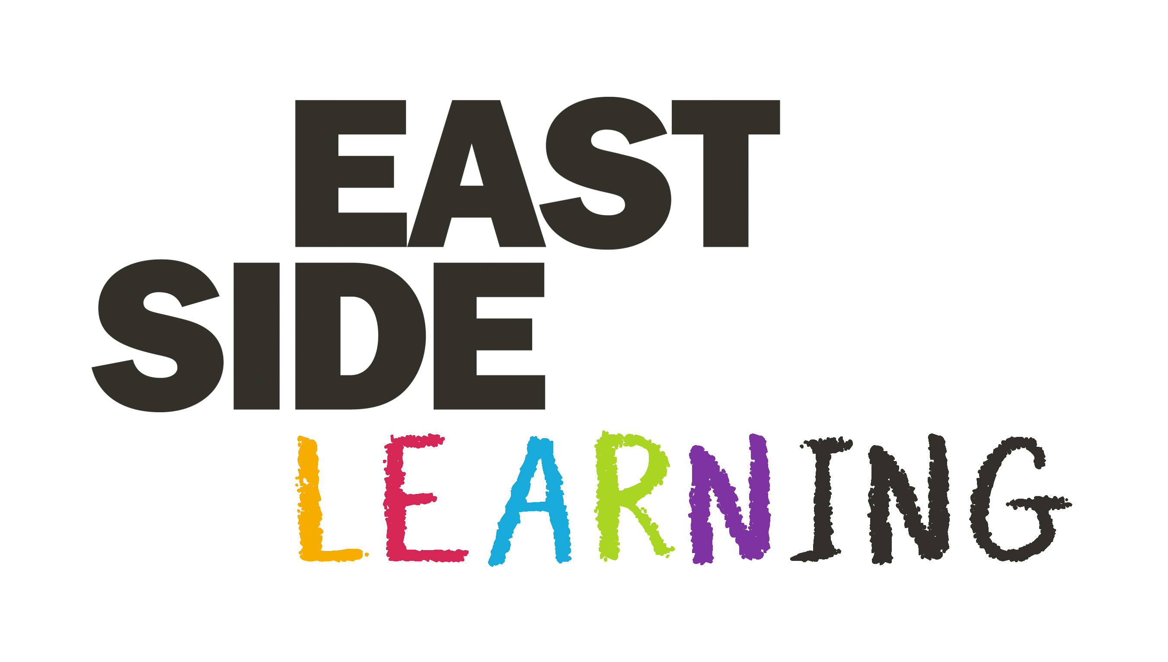

EastSide Learning was established in 2014 and our vision is to support every child and young person in east Belfast to aspire, achieve and thrive.

EastSide Learning continues to connect communities with schools, providing strategic support and co-ordination for informed and effective interventions to improve outcomes for children and their parents.

Our Framework document, reviewed and updated in 2025, re-framed our priorities to reflect progress made and current circumstances and new needs arising from the impact of the pandemic:

Championing Early Years Development
Supporting children and families in the earliest years through relational and evidence-based approaches, building strong social, emotional, and cognitive foundations for lifelong learning.
There will be a focus on:
- Strengthening the Early Years System
- Family and Communities as Partners
- Speech, Language, and Brain Development
- Networks, Collaboration, and Professional Development

Embedding Wellbeing and Trauma-Informed Practice
Promote emotional wellbeing and resilience across homes, schools and communities by supporting wellbeing, trauma-informed and relational practices.

There will be a focus on:
- Training and Knowledge Sharing Across the System
- Embedding Consistent Practice
- Strategic Partnerships
- Capturing Evidence of Impact

Strengthening Numeracy, Literacy, and Core Skills for Life
Focus on skills that unlock opportunity, particularly numeracy and literacy while building the confidence, aspiration and curiosity that support lifelong learning.
There will be a focus on:
- Literacy and Numeracy Support and Early Intervention
- Empowering Parents and Community Learning
- Holistic Support and Core Skills for Life
- Inclusive and Adaptive Learning

Supporting Confident Transitions and Diverse Education Pathways
Ensure smooth, supported transitions through all educational stages and promote respect for multiple pathways to thrive.
There will be a focus on:
- All Transition Stages for Children and Young People
- Exploring Diverse Pathways and Encouraging Curiosity
- Holistic and Family-Centred Support
- Enabling Inclusive Transitions Across Educational, Cultural, and Developmental Stages

