Job Description ESP/ESGM22

Project: EastSide Greenways

Job Title: EastSide Greenways Manager

Location: EastSide Partnership, Avalon House

Reports to: Chief Executive, EastSide Partnership

Terms and conditions

Salary: NJC Point 32-43, currently £35,745 to £46,845 + 7.5% pension.

Contract: This is a permanent post, however it is dependent on future funding. Job subject to 6 month probation period.

Holidays: 25 days per year plus statutory holidays.

Hours of work: 37.5 hours per week but willingness to work flexible hours including evenings and weekends essential.

EastSide Partnership is only able to accept applications from those individuals who are currently eligible to work in the UK. We may only interview those applicants who appear, from the information provided, to be the most suitable in terms of the person specification.

Main Purpose of Job
The main purpose of this role is to support the EastSide Greenways (ESG) Board in delivering its key objectives, through the provision of strong leadership and an ambitious and confident vision for regeneration in east Belfast. Working with key stakeholders, with the support of the ESG Board, the Manager will secure the necessary resources required to deliver the Board objectives.
_________________________________________________________

Summary of responsibilities and personal duties

- To deliver the EastSide Greenways strategic plan to include the protection and enhancement of the Connswater Community Greenway and to advocate for the potential development opportunities for a greenway network across east Belfast
- To play a leading role in enabling the ESG Board to develop and deliver its strategic thinking, planning and positioning for the long term sustainability of ESG including Connswater Community Greenway
- To prepare proposals and bids to secure funding from the public, private and/or philanthropic sectors and other income generation to ensure future sustainability
- To maintain and develop the existing strategic partnership agreement with Belfast City Council and ensure that the Memorandum of Understanding between both parties is being delivered. This includes ensuring the Connswater Community Greenway is managed and maintained to a high standard by Belfast City Council (and other relevant agencies)
- To champion ESG by developing and maintaining positive collaborative partnership arrangements with all relevant stakeholders, across all sectors, locally, nationally and internationally
- To work with the Chairperson and Board to provide effective leadership and to ensure the Board is fit for purpose through structured programmes of Board development tailored to identified needs
- To lead and manage ESG staff members ensuring their professional performance and development needs are monitored and addressed through appraisal and that the culture of a learning organisation delivering high quality services permeates throughout the team
- To ensure that all funder requirements and expectations are met
- To ensure that sound financial management and corporate governance systems and processes are in place to enable Board objectives and financial duties to be met and that financial performance is effectively monitored by the Board
- To advise the Board on all strategic issues, and on the need for external advice and to ensure that the Board is kept fully informed of performance issues and potential risks
- To advocate for and promote the delivery of a wider greenway network across east Belfast through the EastSide Greenways concept plan, in partnership with key agencies such as Department for Infrastructure, Belfast City Council and Sustrans
- To draw on best practice from the delivery of Connswater Community Greenway, be a strong voice for greenway development locally and internationally, sharing vision and learning at key visits, forums and networks
- To oversee and manage the delivery of an annual animation programme of events and activities along the Connswater Community Greenway, in partnership with other EastSide Partnership (ESP) companies (arts, education, tourism etc.), Belfast City Council and other key partners
- To ensure that all ESG delivered programmes, events and activities comply with relevant legislation, health and safety requirements and current best practice
- To work collaboratively with other ESP companies and partner organisations along the Connswater Community Greenway route or from outside the catchment area, to develop and deliver complementary programmes and events that will support the aims and objectives of ESG
- To encourage the use of C.S. Lewis Square as a community and commercial asset
- To promote Connswater Community Greenway including C.S. Lewis Square as tourism products with support from EastSide Tourism and the core ESP team
- To oversee the marketing and communications of ESG and Connswater Community Greenway; promoting a positive image and use of the space with support from ESP communications staff
- To ensure the Connswater Community Greenway is effectively monitored and evaluated to assess social, economic and environmental impact in partnership with best practice research such as Queen’s University Belfast
- To contribute to the overall strategic management of ESP through the management team and work collaboratively with ESP colleagues to fulfil mutual objectives and deliver shared programmes where appropriate
- To act in accordance with ESP policies and procedures
- To undertake such other relevant duties as may from time to time be required.

Person Specification ESP/ESGM22

 | Essential | Desirable
Experience | A minimum of 2 years’ experience gained in the last 10 years:  -managing groups of staff and volunteers  -engaging and working directly with stakeholders including communities and residents  -working with the environment  -managing programmes and projects  -managing events and activities  -managing budgets  -developing successful funding proposals | -Experience of community development  -Experience of partnership working  -Broad knowledge of environmental issues relevant to the Connswater Community Greenway area  -Experience of creating and using resources to help people interpret and understand the environment
Attainments/ Education | -A third level qualification | -A management qualification
Skills | -Excellent communication skills- presentation, conversing with a diverse range of people at all levels, writing reports for a wide range of stakeholders  -Effective organisation skills – ability to manage and prioritise workload and meet deadlines  -Ability to lead and motivate team(s) - co-ordinating, motivating and leading staff, volunteers and / or community groups  -Ability to establish and maintain excellent working relationships and partnerships with a broad range of stakeholders, individuals and organisations, engendering trust and developing networks to support delivery  -Ability to anticipate and identify issues and potential risks and take a proactive approach to resolving them  -Ability to prepare, monitor and review budgets and work plans | -Understanding of Health and safety and risk management including undertaking risk assessments  -Monitoring and evaluation  -Gathering and analysing information and evidence relevant to improving any aspect of the CCG
Disposition | -Well presented & inspires confidence  -Self-motivated and initiative taking  -Ability to work collaboratively and as part of a team  -Ability to deal with multiple projects and determine priorities
Knowledge & Values | -Knowledge of issues relevant to Connswater Commnity Greenway and greenway development  -Knowledge of EastSide Partnership  -Commitment to regeneration and a partnership approach  -Committed to equality and diversity
Circumstances | -Willingness to work flexible hours including evenings and weekends

Equal Opportunities Monitoring Form ESP/ESGM22

Ref No: ESP/ESGM22 Private & Confidential

We are an Equal Opportunity Employer. We do not discriminate on grounds of religious belief or political opinion. We practice equality of Opportunity in employment and select the best person for the job.

To demonstrate our commitment to equality of opportunity in employment we need to monitor the community background of our applicants and employees, as required by the Fair Employment and Treatment (NI) Order 1998.

Regardless of whether we practice religion, most of us in Northern Ireland are seen as Catholic or Protestant. We are therefore asking you to indicate your community background by ticking the appropriate box below.

I am a member of the Protestant community

I am a member of the Roman Catholic community

I am a member of neither the Protestant nor Roman
Catholic community

Please indicate whether you are: Female

Male

If you do not complete this questionnaire, we are encouraged to use the “residuary” method, which means that we can make a determination on the basis of personal information on file/application form.

Note: It is a criminal offence under the legislation for a person to “give false information in connection with the preparation of the monitoring return”.

Application Process ESP/ESGM22

Application
- Completed applications must arrive by 12.00pm on Friday 27th May.

- Applications will only be accepted by email to Gillian: gillian@eastsidepartnership.com and will be acknowledged by email. If not acknowledged, please contact Gillian on 028 9045 1900

- Application MUST be by letter outlining how you meet all of the criteria in the person specification. The letter must be no longer than 2 x A4 pages, minimum font size 10. You may also include a CV (max 2 x A4 pages, minimum font size 10) but please ensure that if you enclose a CV, you cover how you meet all criteria as detailed in the person specification, in your letter

- To be accepted the application must include the equal opportunities monitoring form

- Only information contained in the letter and accompanying CV will be taken into account, so please ensure that you include all relevant information. Any content exceeding the 2 x A4 limits will be disregarded

- We may only interview those applicants who appear, from the information provided, to be the most suitable in terms of the person specification provided.

Equal Opportunities
- EastSide Partnership is an equal opportunities employer. EastSide Partnership does not permit unlawful discrimination of any kind against any person on grounds which include gender, sexual orientation, marital status, religious belief or political opinion, race or disability. Unlawful discrimination is defined as treating a person less favourably than others are, or would be treated in the same or similar circumstances.

Canvassing
- Canvassing in any form will, if proved to the satisfaction of EastSide Partnership, disqualify a candidate for the appointment

Interviews
- Interviews will be held on Monday 6th June. Please ensure your availability for interview on this date prior to application, as it will not be possible to arrange an alternative date

Job Description
- The duties outlined in the Job Description serve as a guide to the current and major responsibilities of the post. These will inevitably vary as the role develops and the Job Description will be reviewed on a regular basis. Changes will be subject to consultation with the post holder.

Background Information

EastSide Partnership is a local charity leading the regeneration of east Belfast. Working alongside other community-based organisations, elected representatives, statutory agencies and local businesses, EastSide Partnership delivers a wide variety of projects with a clear mission to ‘make east Belfast a better place’ for residents, businesses and visitors.

EastSide Partnership aims to:
- Create an east Belfast that is a thriving cultural hub, where the arts are valued, creativity is for everyone and people are connected with each other and the wider world through EastSide Arts
- Promote the use and development of green open spaces, parks, rivers and off-road transport routes in east Belfast through EastSide Greenways including Connswater Community Greenway
- Help and support children in east Belfast to develop their abilities, reach their potential and experience success, whatever their background through EastSide Learning
- Contribute to the regeneration of east Belfast through the strategic acquisition, development and management of sites and properties through EastSide Property
- Coordinate and deliver responsible, sustainable and impactful culture-led regeneration, pushing boundaries to put east Belfast on the map through EastSide Tourism
- Raise awareness and help alleviate the impact of poverty in inner east Belfast through the Scaffolding Project

For more information please visit www.eastsidepartnership.com

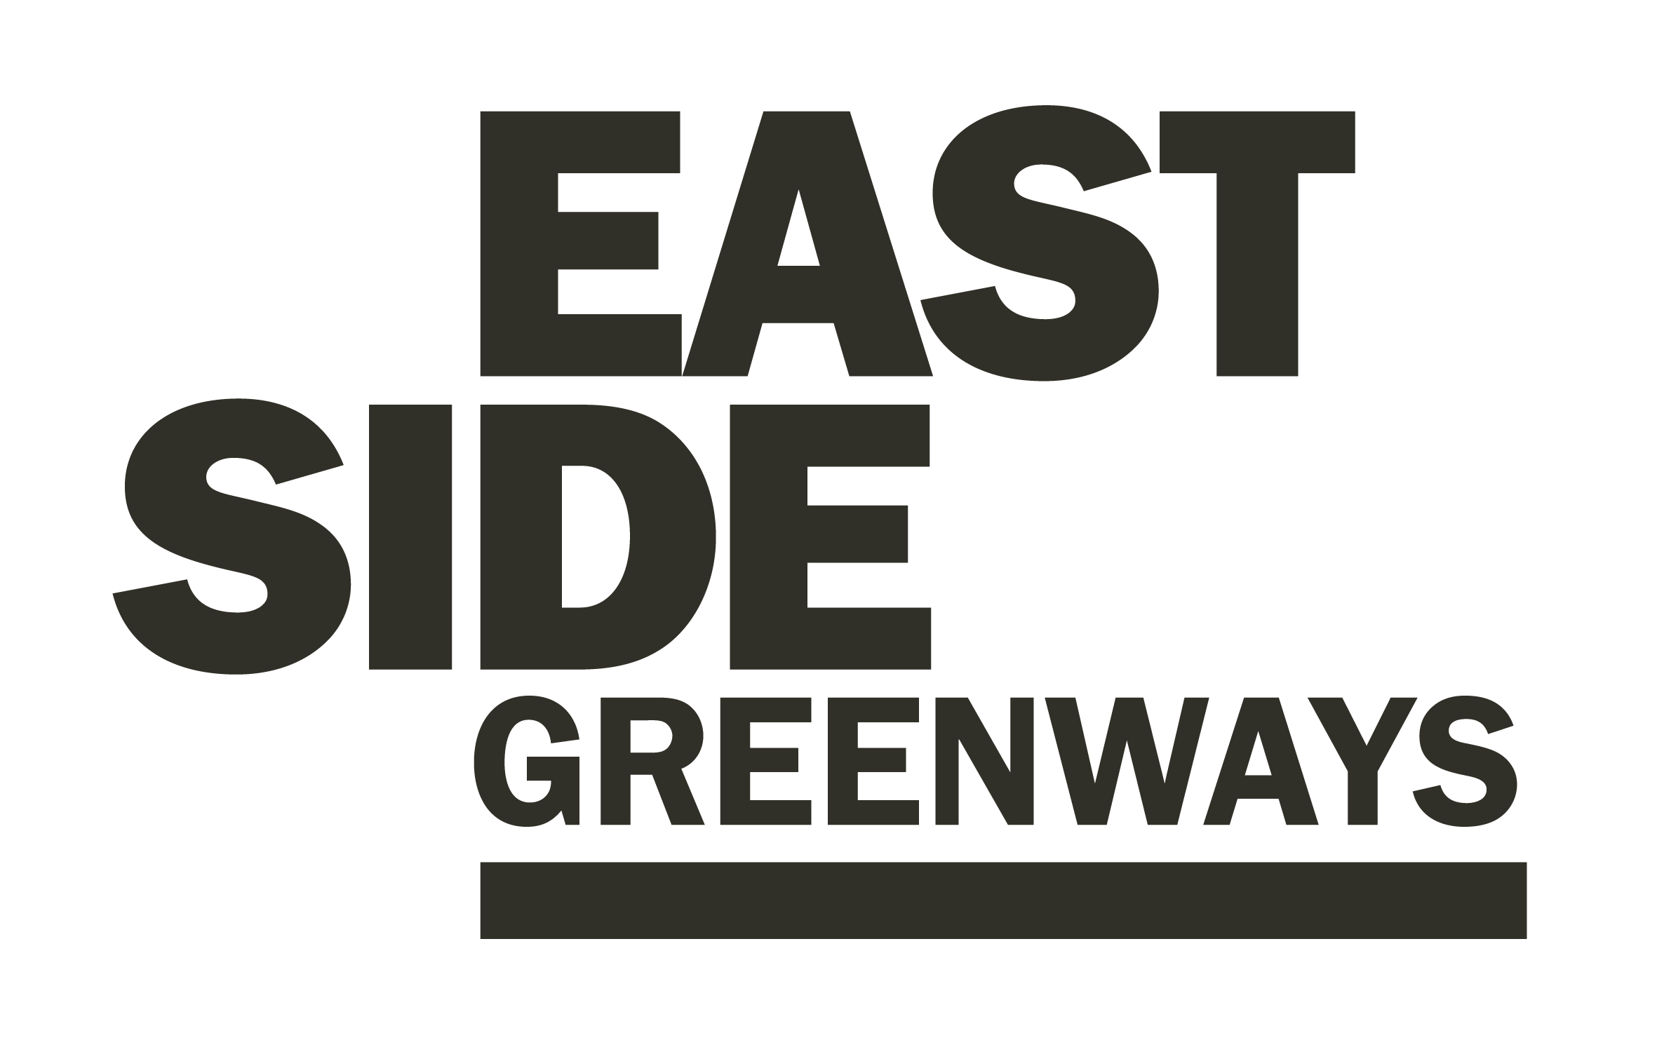

EastSide Greenways- Additional Information

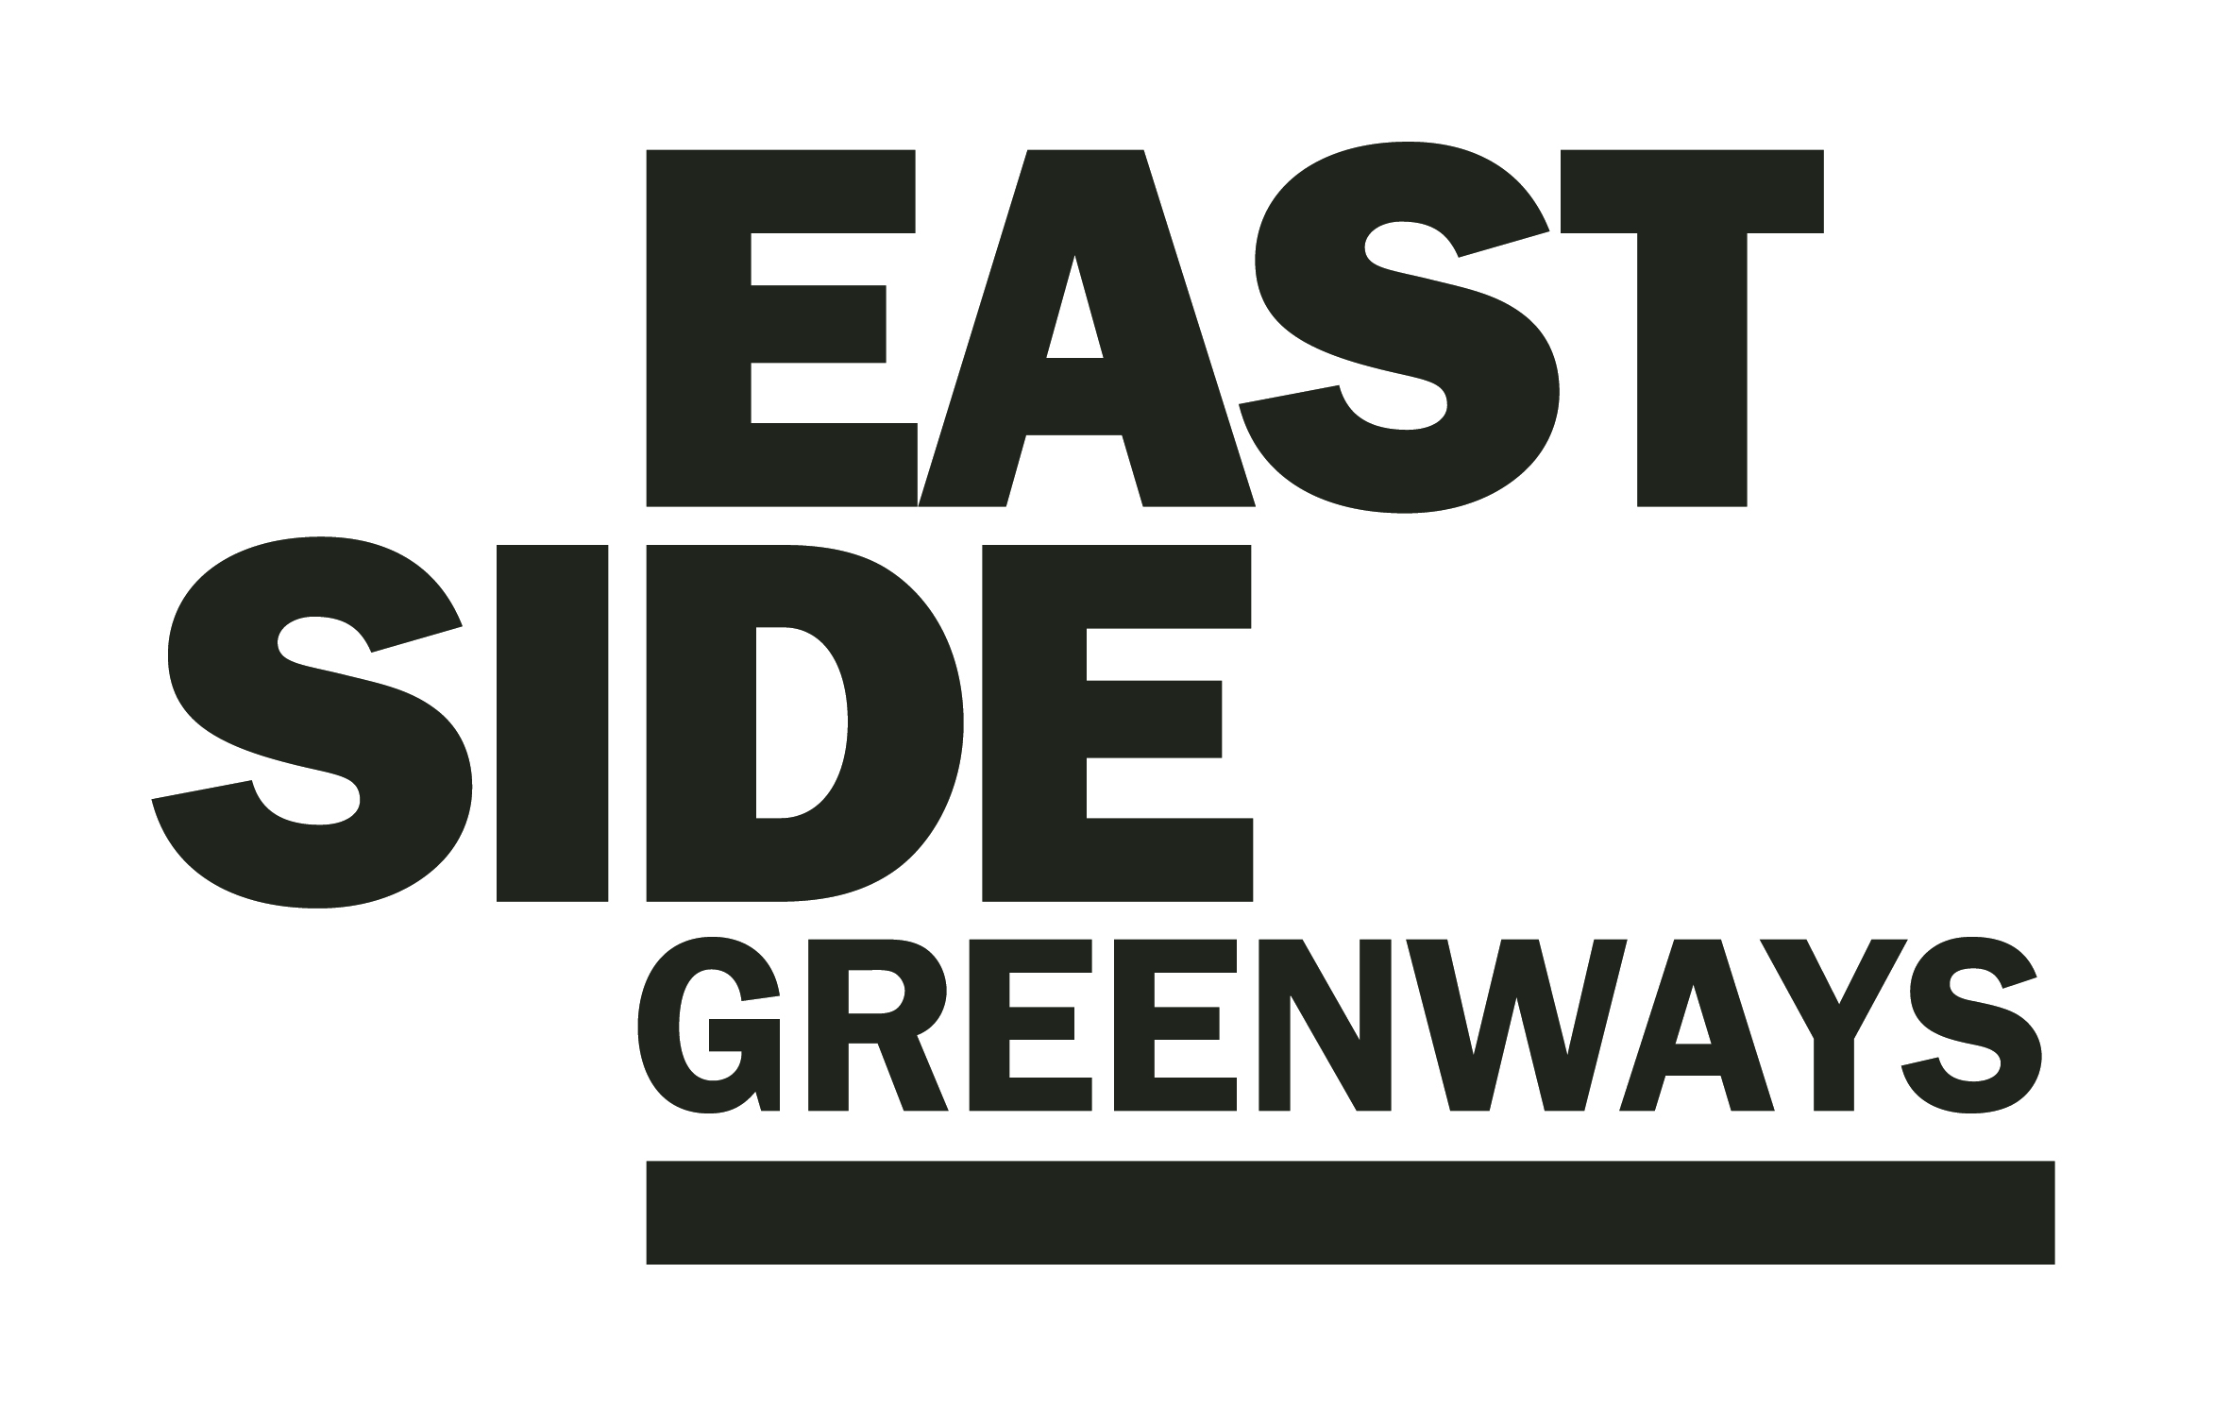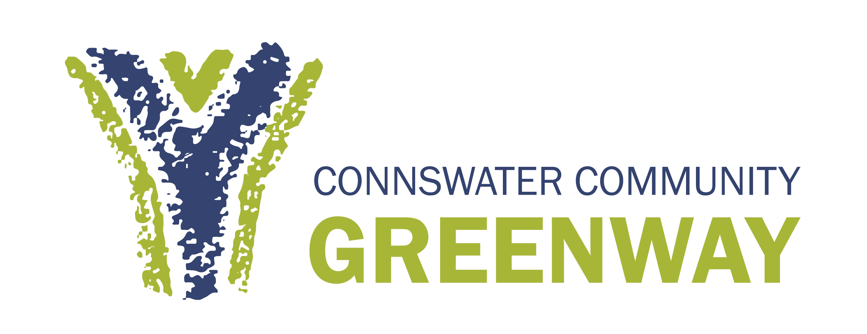

EastSide Greenway’s overall aim is to promote the use and development of green open spaces, parks, rivers and off-road transport routes in east Belfast and to act as a catalyst for the ongoing regeneration or the area.

EastSide Greenway’s strategic objectives are:

- To ensure the sustainability of the Connswater Community Greenway as a living landmark
- To promote the potential for and facilitate the delivery of a wider ‘EastSide Greenways’ network
- To maximise the potential of the Connswater Community and EastSide Greenways to contribute to EastSide’s overarching strategy to deliver social and economic benefit, and enhanced health and well being
- To use the Connswater Community and EastSide Greenways as a catalyst for economic regeneration in east Belfast
- Create new opportunities and promote well - being through the active engagement of local communities and the wider public
- To enhance and conserve the environment along the Connswater Community and EastSide Greenways.

To find out more please visit: http://connswatergreenway.co.uk/ (please note: new website is currently under construction)

