Job Description ESP/ESLPSW19

Project: EastSide Learning

Job Title: EastSide Learning Project Support Worker

Location: EastSide Partnership, Avalon House

Reports to: EastSide Learning Manager

Terms and conditions

Salary: £11,288 per annum (based on 20 hours a week) + 7.5% pension. Starting salary based upon NJC scale point 11 (£21,166 per annum full time). Salary scale NJC 11 - 17.

Contract: Budget has been secured for this post until 30 September 2020, at which stage a full review will be undertaken. The job is subject to a 6 month probation period.

Holidays: 13 days (pro-rated) per year plus statutory holidays.

Hours of work: 20 hours per week, some overtime may be available but willingness to work flexible hours is desirable.

The following gives an indication of the current main duties and responsibilities of the post. The post holder will be expected to work flexibly and carry out any other duties appropriate to the role which may reasonably be required from time to time.

Main Purpose of Job
The main purpose of this role is to:

Support the EastSide Learning Team to deliver the EastSide Learning strategic objectives

Support the successful delivery of our programmes with schools, parents and children to maximise participation.
________________________________________________________________

Summary of responsibilities and personal duties

- Provide a direct link to funders for reporting and monitoring and prepare associated reports, including financial reporting
- Ensure standards are maintained in relation to the data collection guidance set out in funding contracts particularly in relation to participant monitoring data

- Manage the procurement of goods and services in compliance with internal EastSide Partnership and funder requirements: securing competitive quotes and keeping required records

- Updating EastSide Learning social media platforms as required – responding promptly and clearly to information requests

- Assist in the production of marketing and communication materials required to promote EastSide Learning activities and secure high levels of engagement

- Support the organisation and delivery of EastSide Learning events – communicating and engaging with key stakeholders and participants

- Assist in the completion of funding applications to support the delivery of relevant programmes

- Undertake other duties relevant to the role including:

- Provide day to day project administration and support
- Manage relevant and appropriate resources and equipment
- Work alongside communications staff at EastSide Partnership to ensure that all activity is marketed and promoted to maximise participation
- Act in accordance with EastSide Partnership’s policies and procedures
- Undertake such other relevant duties as may from time to time be required

Person Specification ESP/ESLPSW19

 | Essential | Desirable
Education & Experience | - A 3rd Level Qualification and a minimum of 1 years’ experience in a similar role gained in the last 5 years;  OR  A minimum of 3 years’ experience in a similar role  - Experience of monitoring and reporting to funders  - Communicating and engaging effectively with a diverse range of stakeholders | - Experience of partnership working
Skills | - Ability to establish and maintain excellent working relationships and partnerships with a broad range of stakeholders, individuals and organisations  - Effective organisation skills with the ability to manage and prioritise workload and meet deadlines  - Have excellent interpersonal and communication skills  - Ability to use Excel and other Microsoft Office packages  - Ability to produce marketing materials | - Experience of Canva or similar design tools  - Ability to collate and analyse data
Disposition | - Well presented & inspires confidence  - Self-motivated  - Ability to work collaboratively and as part of a team
Knowledge & Values | - Knowledge of EastSide Learning & EastSide Partnership  - Commitment to regeneration and a partnership approach
Circumstances | - Willingness to work flexible hours

Equal Opportunities Monitoring Form ESP/ESLPSW19

Ref No: ESP/ESLPSW19 Private & Confidential

We are an Equal Opportunity Employer. We do not discriminate on grounds of religious belief or political opinion. We practice equality of Opportunity in employment and select the best person for the job.

To demonstrate our commitment to equality of opportunity in employment we need to monitor the community background of our applicants and employees, as required by the Fair Employment and Treatment (NI) Order 1998.

Regardless of whether we practice religion, most of us in Northern Ireland are seen as Catholic or Protestant. We are therefore asking you to indicate your community background by ticking the appropriate box below.

I am a member of the Protestant community

I am a member of the Roman Catholic community

I am a member of neither the Protestant nor Roman
Catholic community

Please indicate whether you are: Female

Male

If you do not complete this questionnaire, we are encouraged to use the “residuary” method, which means that we can make a determination on the basis of personal information on file/application form.

Note: It is a criminal offence under the legislation for a person to “give false information in connection with the preparation of the monitoring return”.

Application Process ESP/ESLPSW19

Application
- Completed applications must arrive by 12pm on Wednesday 4th December 2019.

- Applications will only be accepted by email to gillian@eastsidepartnership.com and will be acknowledged by email. If not acknowledged please contact Gillian on 028 9046 7902

- Application MUST be by letter outlining how you meet all of the criteria in the person specification. The letter must be no longer than 2 x A4 pages, minimum font size 11. You may also include a CV (max 2 x A4 pages, minimum font size 11) but please ensure that if you enclose a CV, you cover how you meet all criteria as detailed in the person specification, in your letter

- To be accepted the application MUST include the monitoring form

- Only information contained in the letter and accompanying CV will be taken into account, so please ensure that you include all relevant information. Any content exceeding the 2 x A4 limit will be disregarded.

- We may only interview those applicants who appear, from the information provided, to be the most suitable in terms of the person specification provided.

Equal Opportunities
- EastSide Partnership is an equal opportunities employer. EastSide Partnership does not permit unlawful discrimination of any kind against any person on grounds which include gender, sexual orientation, marital status, religious belief or political opinion, race or disability. Unlawful discrimination is defined as treating a person less favourably than others are or would be treated in the same or similar circumstances.

Canvassing
- Canvassing in any form will, if proved to the satisfaction of EastSide Partnership, disqualify a candidate for the appointment

Interviews
- Interviews will be held on Monday 9th December 2019. Please ensure your availability for interview on this date prior to application, as it will not be possible to arrange an alternative date

Job Description
- The duties outlined in the Job Description serve as a guide to the current and major responsibilities of the post. These will inevitably vary as the role develops and the Job Description will be reviewed on a regular basis. Changes will be subject to consultation with the post holder.

Background Information

EastSide Partnership is a regeneration charity which delivers a wide variety of projects with a clear mission, ‘to make east Belfast a better place’ for resident and visitors. We work with local councils, statutory agencies, community organisations, elected representatives and businesses to make east Belfast a great place to live, work, visit, invest and be proud of.

Our vision is that east Belfast will be a great place where:
- Residents enjoy good health and well being
- Education is valued and high standards achieved
- Tourism, arts and hospitality are thriving

EastSide Partnership aims to:

- Contribute to physical regeneration in east Belfast by developing key properties through EastSide Property
- Ensure the Connswater Community Greenway is developed and maintained as a destination for all and deliver similar initiatives through EastSide Greenways
- Deliver EastSide Arts festivals, community arts project and support local arts groups
- Facilitate schools and communities to work together to deliver better outcomes for children through EastSide Learning
- Increase visitors to east Belfast and ensure that the potential socio-economic benefits of tourism are maximised at a local level through EastSide Tourism
- Develop a strategic approach and facilitate campaigns, activities and events to alleviate the effects of poverty in east Belfast through the Scaffolding Project

For more information please visit www.eastsidepartnership.com
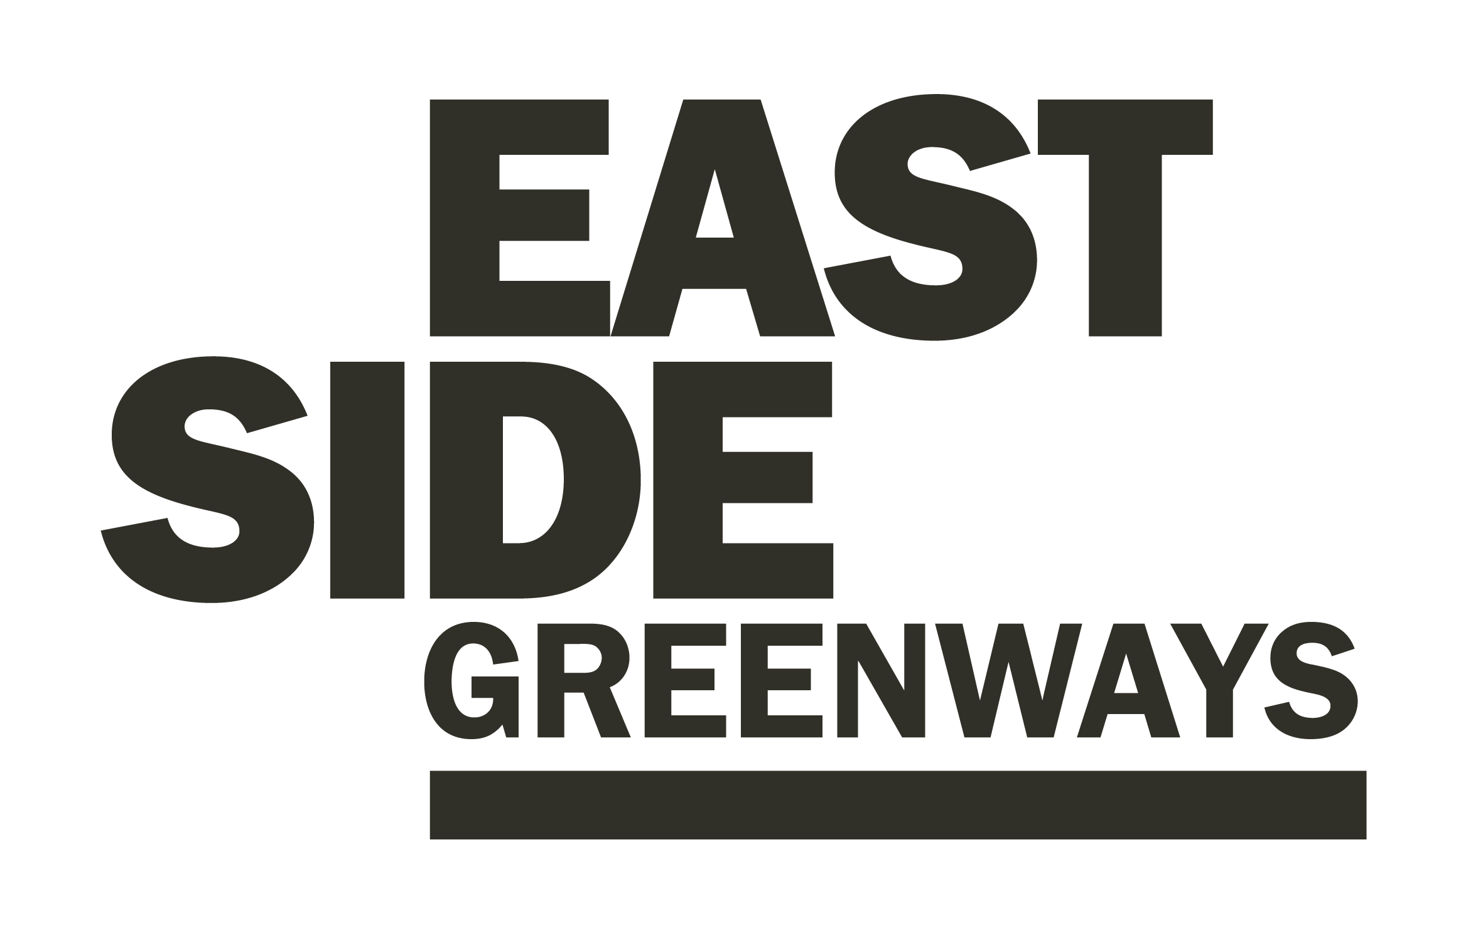

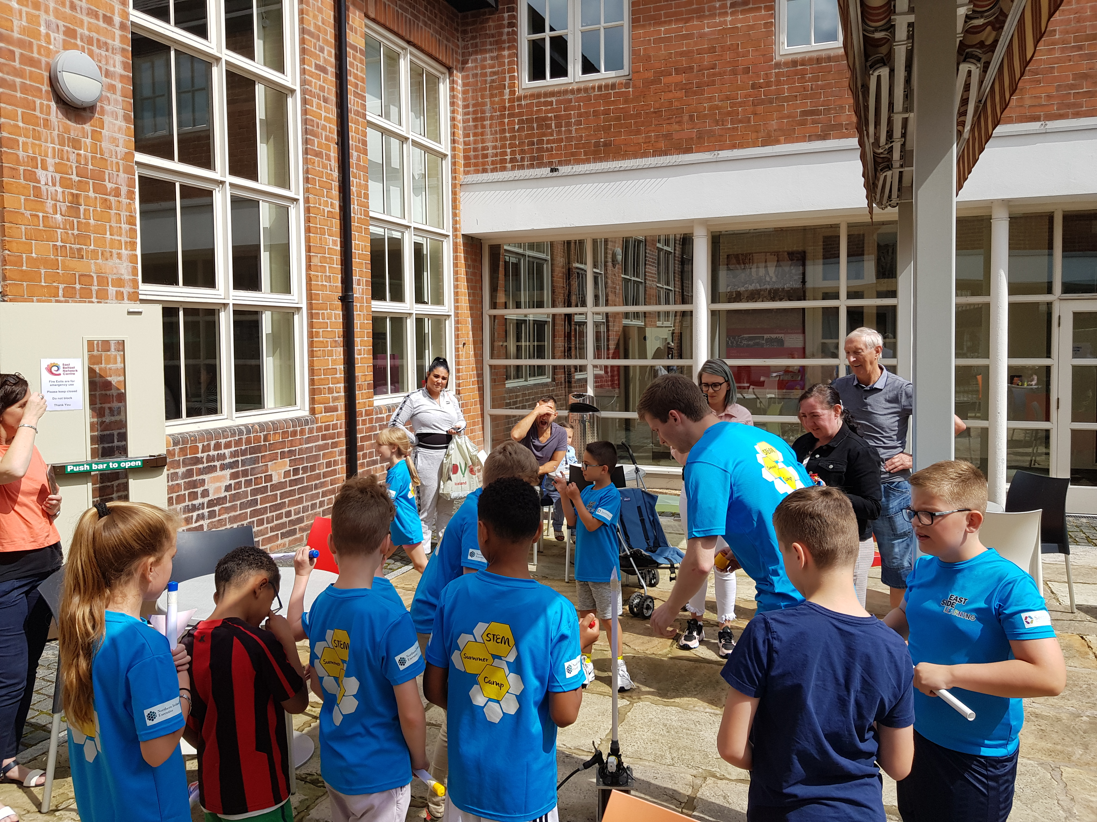

Our Framework document sets out priorities for our work which we believe are at the heart of improving the educational experience of all our children and young people. The Framework recognises that this will take a generational change to make the difference that is needed, to deliver long term impacts.

Our Framework available to view here: https://www.eastsidelearning.co.uk/sites/default/files/ESL-Framework.pdf

Our Aims

- Partnership Working
- Aspiration and Achievement
- Valuing all Education Pathways
- Early Years Development

Our Objectives

- Develop the role of EastSide Learning and provide strategic leadership for education initiatives in east Belfast

- Support and deliver activities that will raise overall standards of education and reduce education inequalities in east Belfast

- Promote and offer opportunities to parents that will help them engage with and support their children’s learning

- Work closely with schools to develop more informed choices for young people in the post primary sector

- Promote the effectiveness of early interventions and build links with the Early Years Network.

Since 2016 we have been implementing a programme of school and community- based supports that have supported schools and their staff, supported parents and their children and ensured that the needs of parents and schools in east Belfast are more widely understood by decision makers.

We have also been able to introduce a step change in strategic coordination and partnership working ethos of the Belfast East early years, primary, post primary and community sectors with the view of improving education and social outcomes for children in the area.

