Job Description ESP/ESLPO22(2)

Project: EastSide Learning

Job Title: Project Officer

Location: EastSide Partnership (Avalon House) and Carew Family Centre

Reports to: EastSide Learning Manager

Terms and conditions

Salary: Starting on NJC Point 19, on a scale of points 19–25, currently £25,927 - £30,095, + 7.5% pension

Contract: This is a permanent post, however it is dependent on future funding, which is currently secured until April 2023. Job subject to 6 month probation period.

Holidays: 25 days per year plus statutory holidays.

Hours of work: 37.5 hours per week but willingness to work flexible hours including evenings and weekends is essential.

The following gives an indication of the current main duties and responsibilities of the post. The post holder will be expected to work flexibly and carry out any other duties appropriate to the role which may reasonably be required from time to time.

Main Purpose of Job
The main purpose of the role is to provide co-ordination and support within the EastSide Learning team; contributing to the planning, development and delivery of programmes to increase school/community links, raise aspirations, and improve outcomes for children and families.

The key role of the Project Officer is to coordinate existing activity, and identify opportunities for developing new activity for children and families, through collaborative working with key partners

The following gives an indication of the current main duties and responsibilities of the post. The post holder will be expected to work flexibly and carry out any other duties appropriate to the role which may reasonably be required from time to time.

Summary of responsibilities and personal duties

- Support the EastSide Learning Manager to deliver EastSide Learning’s strategic objectives

- Develop and maintain detailed project plans for agreed programmes of activity

- Identify opportunities to develop integrated and holistic solutions to supporting learning for children and parents

- Oversee and support sessional/casual staff to deliver activities as required

- Secure maximum participation in programmes; working closely with participants, parents and partners to understand their experience and ensure projects continue to meet their needs

- Undertake impact evaluations as required and produce relevant reports to inform project planning and refine delivery

- Build relationships with key stakeholders and participants to ensure signposting of opportunities for support and engagement

- Help prepare all aspects of project proposals including delivery plans and budgets

- Oversee the collection of data and manage any project evaluation required by funders

- Monitor and track operational progress; escalating any issues with the Manager as required

- Attend and contribute to relevant initiatives/forums/networks to support integrated working, and inform/enhance the work of EastSide Learning

- To assist in the design and production of publicity and marketing materials
- Ensure compliance with the organisational, financial and administrative requirements of EastSide Partnership

- Act in accordance with EastSide Partnership’s policies and procedures

- Undertake such other relevant duties as may from time to time be required

Person Specification ESP/ESLPO22(2)

 | Essential | Desirable
Experience | - Experience in project coordination/delivery in a related field  - Previous experience of co-operating within a team for the delivery of projects  - Experience of managing casual staff, volunteers, and contractors  - Excellent interpersonal and communication skills (verbal & written)  - Experience and knowledge of Microsoft Office and other project management tools  - Experience of a community development approach to programmes or related practices | - Experience working in the community, voluntary or education sector  - Experience of working with vulnerable adults and children  - Experience of gathering and analysing information
Attainments/ Education | - Relevant 3rd Level Degree or Equivalent (e.g. social sciences, education, community development)
Skills | - Excellent written and oral communication - including the ability to prepare and present reports  - Ability to effectively collect and analyse data, and prepare evaluations  - The ability to work as a member of a team, providing support to colleagues in an efficient and effective manner  - Excellent organisational skills and a methodical approach to organising administration  - An ability to liaise and communicate effectively with a wide range of stakeholders at different levels  - Ability to maintain and build relationships with participants and partners  - An ability to evaluate outcomes to improve project delivery  - Capability for flexibility and initiative in working practices.  - Ability to multitask and prioritise workload to deliver outcomes  - Skills and experience in budget/resource management | - Experience of developing and/or delivering programmes and activity focused on children and families
Disposition | - Energetic & inspires confidence  - Self-motivated and initiative taking  - Team player
Knowledge & Values | - Knowledge of issues relevant to EastSide Learning  - Knowledge of the community, education sector, schools or family support.  - Knowledge of EastSide Partnership  - Committed to equality and diversity  - Commitment to regeneration and a partnership approach | - Broad understanding of the education context in East Belfast  - An awareness of the issues impacting the children and families
Circumstances | - Willingness to work flexible hours including evenings and weekends  - Access to transport to carry out the needs of the post

Equal Opportunities Monitoring Form ESP/ESLPO22(2)

Ref No: ESP/ESLPO22(2) Private & Confidential

We are an Equal Opportunity Employer. We do not discriminate on grounds of religious belief or political opinion. We practice equality of Opportunity in employment and select the best person for the job.

To demonstrate our commitment to equality of opportunity in employment we need to monitor the community background of our applicants and employees, as required by the Fair Employment and Treatment (NI) Order 1998.

Regardless of whether we practice religion, most of us in Northern Ireland are seen as Catholic or Protestant. We are therefore asking you to indicate your community background by ticking the appropriate box below.

I am a member of the Protestant community

I am a member of the Roman Catholic community

I am a member of neither the Protestant nor Roman
Catholic community

Please indicate whether you are: Female

Male

If you do not complete this questionnaire, we are encouraged to use the “residuary” method, which means that we can make a determination on the basis of personal information on file/application form.

Note: It is a criminal offence under the legislation for a person to “give false information in connection with the preparation of the monitoring return”.

Application Process ESP/ESLPO22(2)

Application
- Completed applications must arrive by Tuesday 31st May 2022 at 12pm

- Applications will only be accepted by email to gillian@eastsidepartnership.com and will be acknowledged by email. If not acknowledged please contact Gillian on 028 90451900

- Application MUST be by letter outlining how you meet all of the criteria in the person specification. The letter must be no longer than 2 x A4 pages, minimum font size 11. You may also include a CV (max 2 x A4 pages, minimum font size 11) but please ensure that if you enclose a CV, you cover how you meet all criteria as detailed in the person specification, in your letter

- To be accepted the application MUST include the monitoring form

- Only information contained in the letter and accompanying CV will be taken into account, so please ensure that you include all relevant information. Any content exceeding the 2 x A4 limit will be disregarded

- We may only interview those applicants who appear, from the information provided, to be the most suitable in terms of the person specification provided.

Equal Opportunities
- EastSide Partnership is an equal opportunities employer. EastSide Partnership does not permit unlawful discrimination of any kind against any person on grounds which include gender, sexual orientation, marital status, religious belief or political opinion, race or disability. Unlawful discrimination is defined as treating a person less favourably than others are, or would be treated in the same or similar circumstances.

Canvassing
- Canvassing in any form will, if proved to the satisfaction of EastSide Partnership, disqualify a candidate for the appointment

Interviews
- Interviews will be held on Wednesday 8th June. Please ensure your availability for interview on this date prior to application, as it will not be possible to arrange an alternative date

Job Description
- The duties outlined in the Job Description serve as a guide to the current and major responsibilities of the post. These will inevitably vary as the role develops and the Job Description will be reviewed on a regular basis. Changes will be subject to consultation with the post holder.

Background Information

EastSide Partnership is a local charity leading the regeneration of east Belfast. Working alongside other community-based organisations, elected representatives, statutory agencies and local businesses, EastSide Partnership delivers a wide variety of projects with a clear mission to ‘make east Belfast a better place’ for residents, businesses and visitors.

Our vision is that east Belfast will be a great place where:
- Residents enjoy good health and well being
- Education is valued and high standards achieved
- Tourism, arts and hospitality are thriving

EastSide Partnership aims to:
- Create an east Belfast that is a thriving cultural hub, where the arts are valued, creativity is for everyone and people are connected with each other and the wider world through EastSide Arts
- Promote the use and development of green open spaces, parks, rivers and off-road transport routes in east Belfast through EastSide Greenways including Connswater Community Greenway
- Help and support children in east Belfast to develop their abilities, reach their potential and experience success, whatever their background through EastSide Learning
- Contribute to the regeneration of east Belfast through the strategic acquisition, development and management of sites and properties through EastSide Property
- Coordinate and deliver responsible, sustainable and impactful culture-led regeneration, pushing boundaries to put east Belfast on the map through EastSide Tourism
- Raise awareness and help alleviate the impact of poverty in inner east Belfast through the Scaffolding Project

For more information please visit www.eastsidepartnership.com
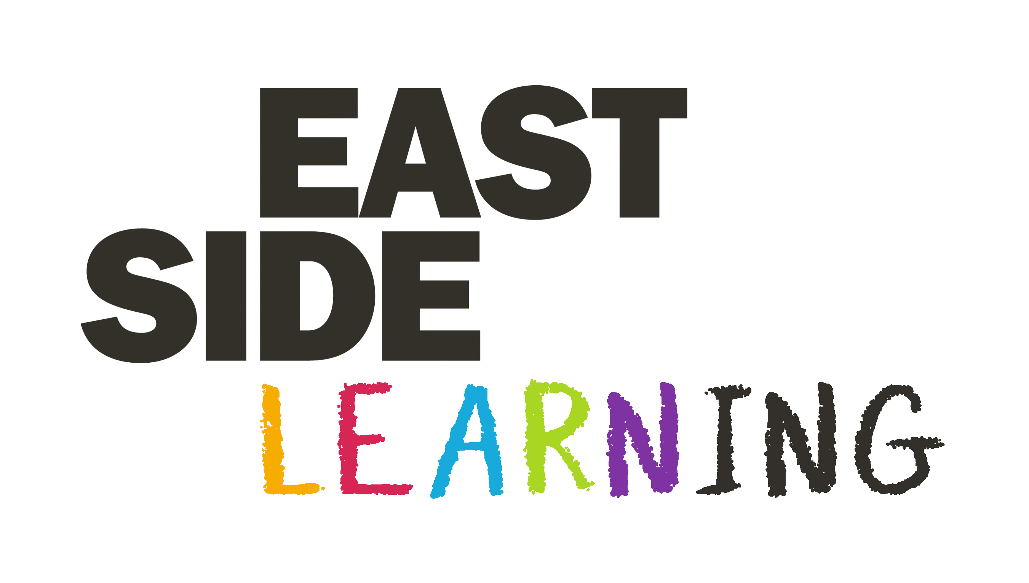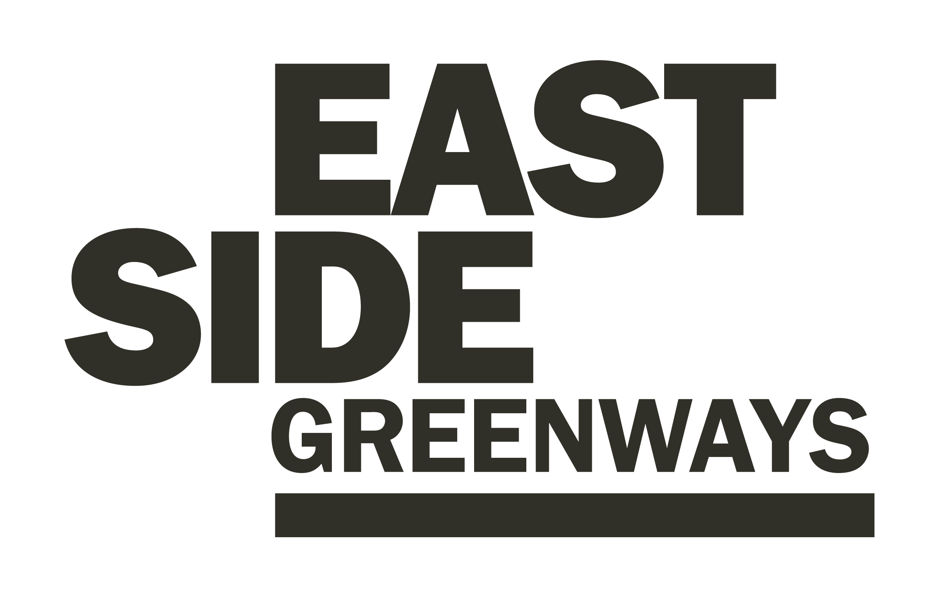

EastSide Learning was established in 2014 and our overall aim is to help and support children in east Belfast to develop their abilities; reach their potential and experience success; whatever their background.

EastSide Learning continues to connect communities with schools, to provide strategic support and co-ordination for informed and effective interventions to improve outcomes for children and their parents.

Our Framework document, reviewed and updated in 2020, re-framed our priorities to reflect progress made and current circumstances and new needs arising from the impact of the pandemic:

- Building Aspiration and improving achievement
To provide activities that will support parents to become more confident and involved in their children’s learning, offer training and advice, and broker improved relationships with schools - contributing to developing a positive community ethos that values education and improves performance

- Early Years Development
To secure more investment in early years settings and our primary schools. Supporting and building the EastSide Early Years Network and the EastSide Early Learning Community to improve links across phases, share good practice and improve training for all early year’s staff

- Supporting Smoother Transitions
To support smoother transitions throughout the system from early years to leaving school; focussing on confidence building and social and emotional wellbeing to ensure readiness to learn at all stages

- Valuing All Educational Pathways and enriching learning
To develop new and enhance existing opportunities that broaden the skill set and develop the interests of children and young people in a range of STEAM Creative and World Around Us activities

- Collaboration, Coordination and Working in Partnership
To bring all the key organisations together to ensure good planning, improve how we communicate with each other and thereby improve the quality and delivery of services.

For more information please visit: www.eastsidelearning.co.uk

