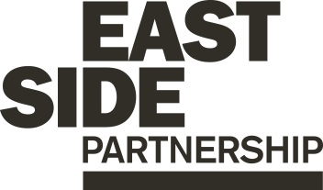

Job Description ESP/ESGYPSW22

Project: EastSide Greenways

Job Title: Youth Project Support Worker

Location: EastSide Partnership, Avalon House

Reports to: EastSide Greenways Manager

Terms and conditions

Salary: Starting on NJC Point 7, on a scale of points 7-17, currently £13,629 - £16,613 pro rata (full-time scale £20,444 - £24,920), + 7.5% pension

Contract: This post is a permanent post, however it is dependent on future funding, which is currently secured until August 2024. Job subject to 6 month probation period.

Holidays: 16.5 days (pro rata) per year plus statutory holidays.

Hours of work: 25 hours per week but willingness to work flexible hours including evenings and weekends is essential.

The following gives an indication of the current main duties and responsibilities of the post. The post holder will be expected to work flexibly and carry out any other duties appropriate to the role which may reasonably be required from time to time.

Main Purpose of Job

The main purpose of this role is to:

Support the ESG team in the planning, coordination and delivery of the EastSide Greenways Personal Youth Development Programme (PYDP) in accordance with the terms and conditions outlined in the International Fund for Ireland Letter of Offer.

Summary of responsibilities and personal duties

- Support the development, planning and delivery of a 2 year programme working intensively with at risk young people aged 16 – 25 years not in employment, education and training focusing on; personal development & good relations, skills & social development, education & employability development and developing community champions .
- Support the recruitment of 15 young people to engage with the PYDP.

- Assist in the planning and delivery of 3 days of engagement sessions per week throughout the 2 year programme themed on the above focus areas.

- Support the planning and delivery of training and skills development including OCN accredited training.

- Assist in booking relevant third party facilitators, trainers and suppliers to deliver elements of the programme where required.

- Support the planning and delivery of trips, visits, volunteering opportunities, educational and vocational talks for programme participants.

- Attend and take minutes at a quarterly steering group made up of key representatives in east Belfast in relation to the PYDP.

- Support the maintenance of accurate records, stored appropriately and with respect to confidentiality.

- Support regular monitoring and evaluation of the programme through administration.

- Attend community forums and liaise with key stakeholders on behalf of ESG, to support the Youth Project Officer when required.

- Undertake other duties relevant to the role including:

- Provide day to day project administration and support
- Assist in overseeing management of appropriate resources and equipment
- Attend training courses and conferences as required
- Assist in reporting against objectives to ensure outcomes are being met and that monitoring and evaluation is undertaken
- Act in accordance with EastSide Partnership’s policies and procedures
- Undertake such other relevant duties as may from time to time be required

Person Specification ESP/ESGYPSW22
 | Essential | Desirable
Education/  Experience | - A 3rd Level Qualification in a youth related field and a minimum of 1 years’ experience in a similar role gained in the last 5 years;  OR  A minimum of 3 years’ experience in a similar role  - Experience working with young people | - Experience of;  - Facilitation or delivering training activities
Skills | - Ability to establish and maintain positive relationships with young people  - Ability to be creative, innovative and work on own initiative  - Effective organisation skills with the ability to manage and prioritise workload and meet deadlines  - Excellent interpersonal and communication skills | -Ability to report on programme outcomes
Disposition | - Well presented & inspires confidence  - Self-motivated and initiative taking  - Passionate, inspiring and dynamic  - Ability to work collaboratively and as part of a team  - Flexible and pragmatic  -Ability to work with young people  -Offers a positive role model for young people
Knowledge & Values | - Knowledge of Connswater Community Greenway, EastSide Greenways and EastSide Partnership  -Knowledge of the Youth Sector in Belfast  - Commitment to regeneration and a partnership approach
Circumstances | - Willingness to work flexible hours including evenings and weekends

Equal Opportunities Monitoring Form ESP/ESGYPSW22

Ref No: ESP/ESGYPSW22 Private & Confidential

We are an Equal Opportunity Employer. We do not discriminate on grounds of religious belief or political opinion. We practice equality of Opportunity in employment and select the best person for the job.

To demonstrate our commitment to equality of opportunity in employment we need to monitor the community background of our applicants and employees, as required by the Fair Employment and Treatment (NI) Order 1998.

Regardless of whether we practice religion, most of us in Northern Ireland are seen as Catholic or Protestant. We are therefore asking you to indicate your community background by ticking the appropriate box below.

I am a member of the Protestant community

I am a member of the Roman Catholic community

I am a member of neither the Protestant nor Roman
Catholic community

Please indicate whether you are: Female

Male

If you do not complete this questionnaire, we are encouraged to use the “residuary” method, which means that we can make a determination on the basis of personal information on file/application form.

Note: It is a criminal offence under the legislation for a person to “give false information in connection with the preparation of the monitoring return”.

Application Process ESP/ESGYPSW22

Application
- Completed applications must arrive by 12pm on Thursday 18th August 2022

- Applications will only be accepted by email to heather@eastsidepartnership.com and will be acknowledged by email. If not acknowledged please contact Heather on 028 9045 1900

- Application MUST be by completion of the Application Form with minimum font size 11. You may also include a CV (max 2 x A4 pages, minimum font size 11) but please ensure that if you enclose a CV, you cover how you meet all criteria as detailed in the person specification, in your application.

- To be accepted the application MUST include the monitoring form

- Only information contained in the letter and accompanying CV will be taken into account, so please ensure that you include all relevant information. Any content exceeding the 2 x A4 limit will be disregarded

- We may only interview those applicants who appear, from the information provided, to be the most suitable in terms of the person specification provided.

Equal Opportunities
- EastSide Partnership is an equal opportunities employer. EastSide Partnership does not permit unlawful discrimination of any kind against any person on grounds which include gender, sexual orientation, marital status, religious belief or political opinion, race or disability. Unlawful discrimination is defined as treating a person less favourably than others are, or would be treated in the same or similar circumstances.

Canvassing
- Canvassing in any form will, if proved to the satisfaction of EastSide Partnership, disqualify a candidate for the appointment

Interviews
- Interviews will be held on Wednesday 24th August. Please ensure your availability for interview on this date prior to application, as it will not be possible to arrange an alternative date

Job Description
- The duties outlined in the Job Description serve as a guide to the current and major responsibilities of the post. These will inevitably vary as the role develops and the Job Description will be reviewed on a regular basis. Changes will be subject to consultation with the post holder.

Background Information

EastSide Partnership is a local charity leading the regeneration of east Belfast. Working alongside other community-based organisations, elected representatives, statutory agencies and local businesses, EastSide Partnership delivers a wide variety of projects with a clear mission to ‘make east Belfast a better place’ for residents, businesses and visitors.

Our vision is that east Belfast will be a great place where:
- Residents enjoy good health and well being
- Education is valued and high standards achieved
- Tourism, arts and hospitality are thriving

EastSide Partnership aims to:
- Create an east Belfast that is a thriving cultural hub, where the arts are valued, creativity is for everyone and people are connected with each other and the wider world through EastSide Arts
- Promote the use and development of green open spaces, parks, rivers and off-road transport routes in east Belfast through EastSide Greenways including Connswater Community Greenway
- Help and support children in east Belfast to develop their abilities, reach their potential and experience success, whatever their background through EastSide Learning
- Contribute to the regeneration of east Belfast through the strategic acquisition, development and management of sites and properties through EastSide Property
- Coordinate and deliver responsible, sustainable and impactful culture-led regeneration, pushing boundaries to put east Belfast on the map through EastSide Tourism
- Raise awareness and help alleviate the impact of poverty in inner east Belfast through the Scaffolding Project

For more information please visit www.eastsidepartnership.com
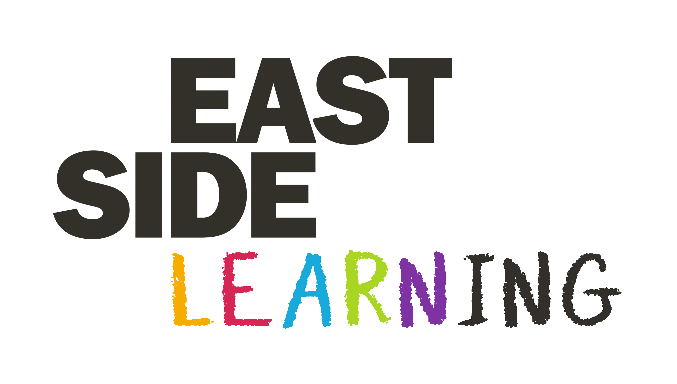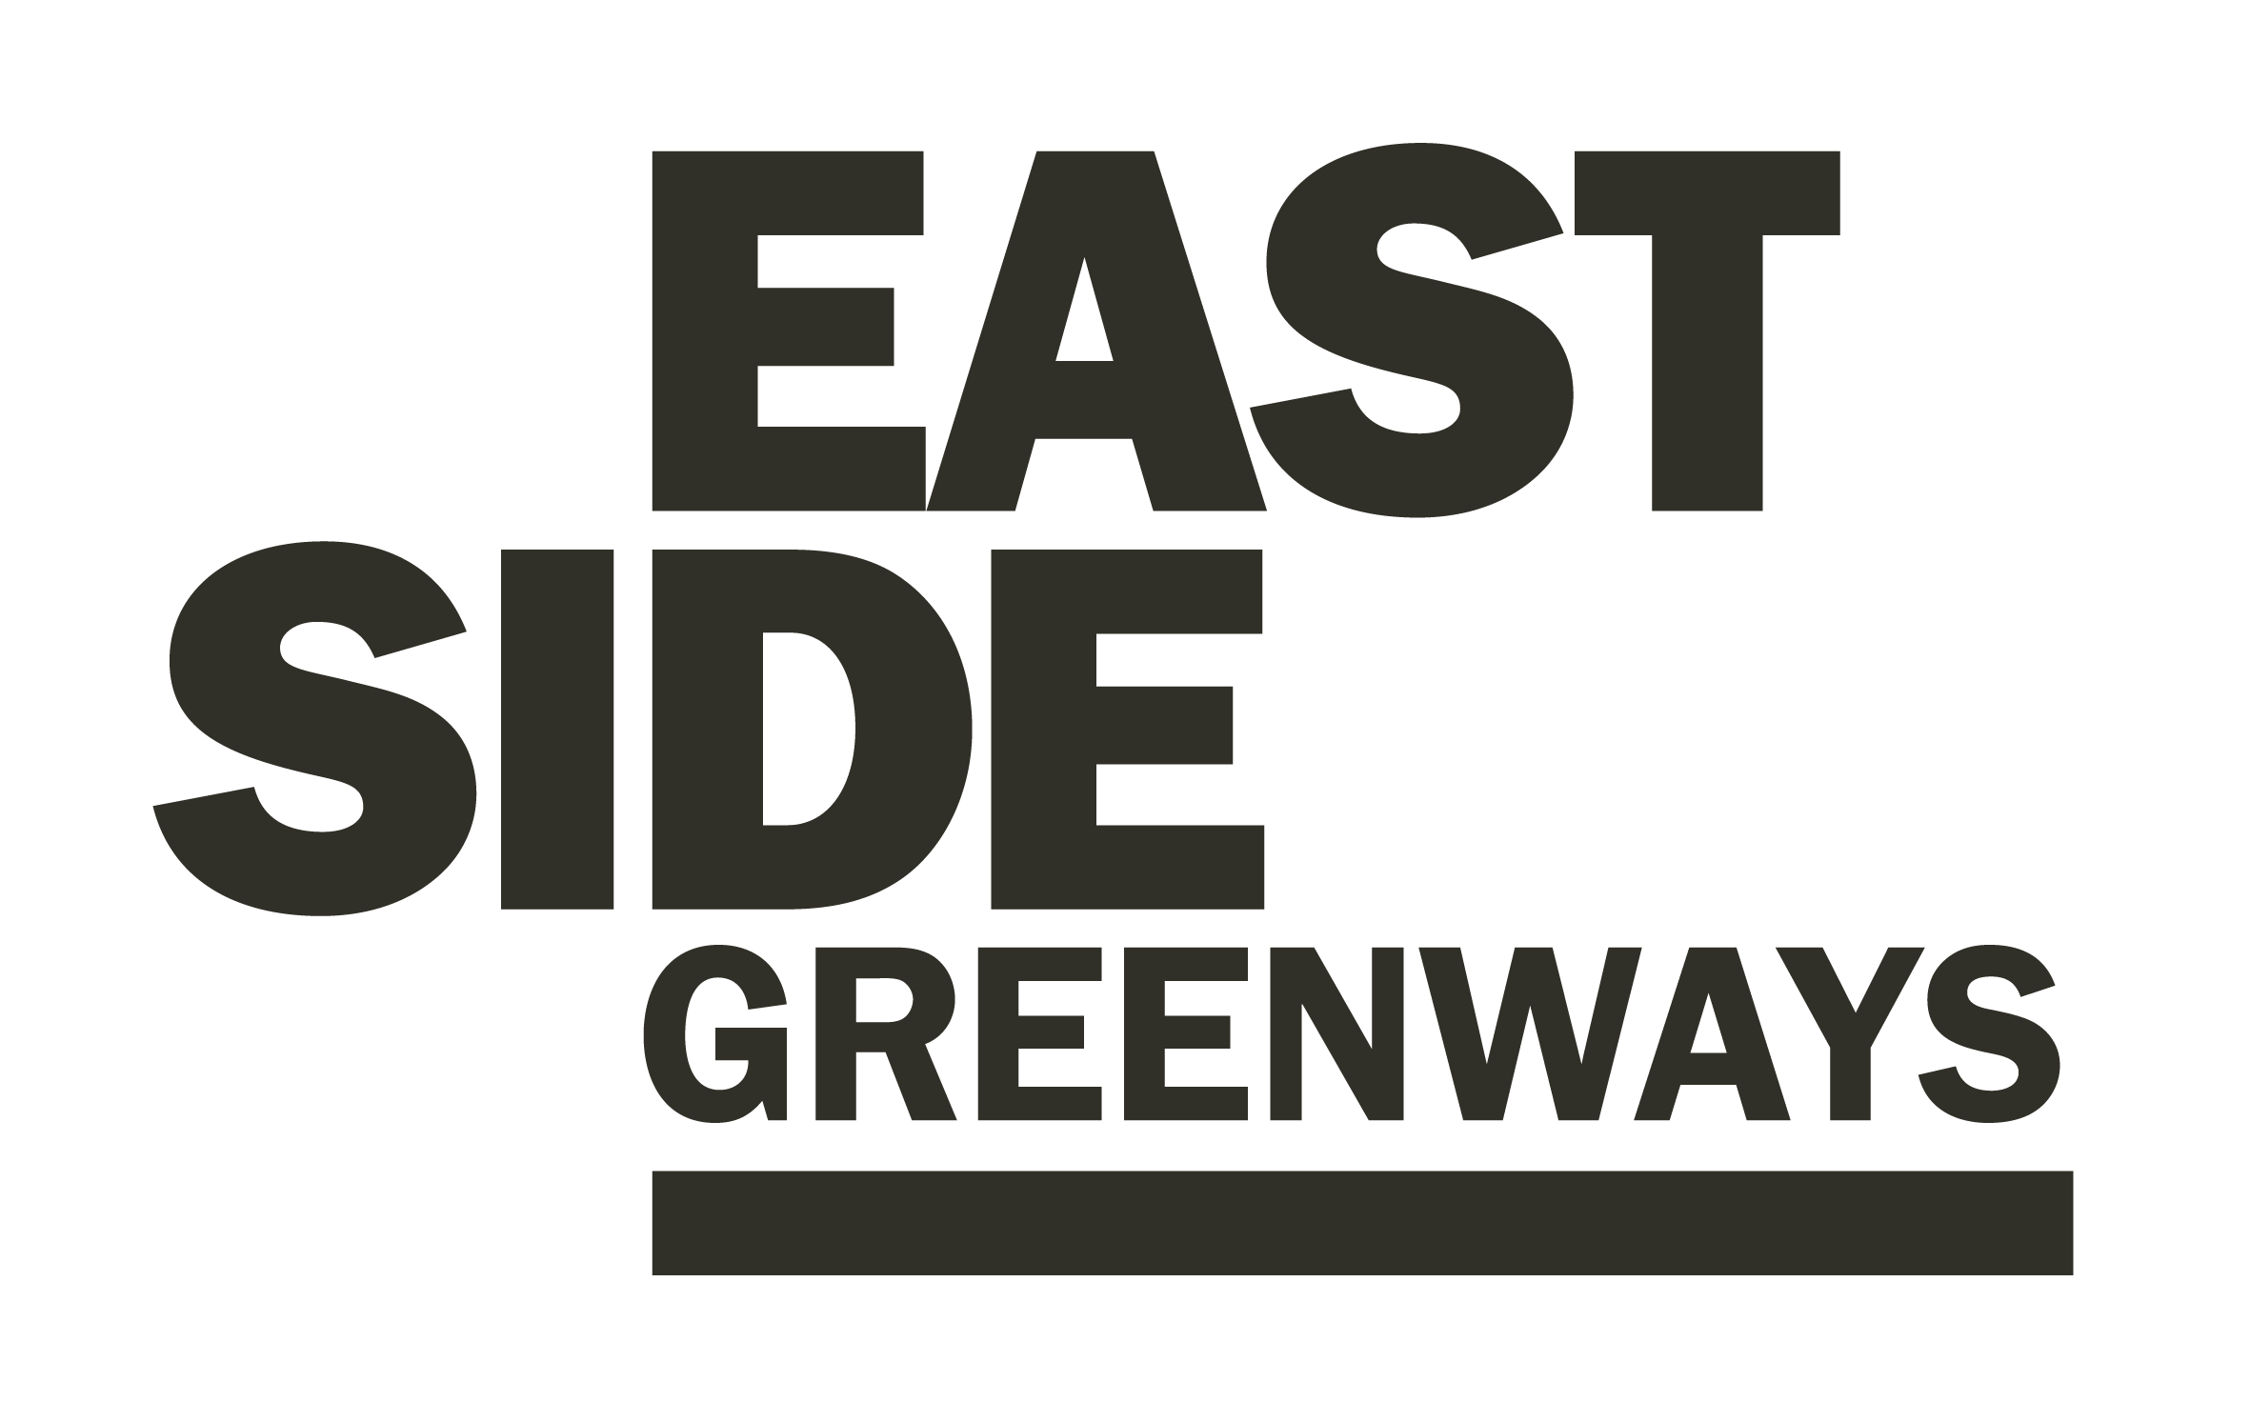

EastSide Greenways- Additional Information

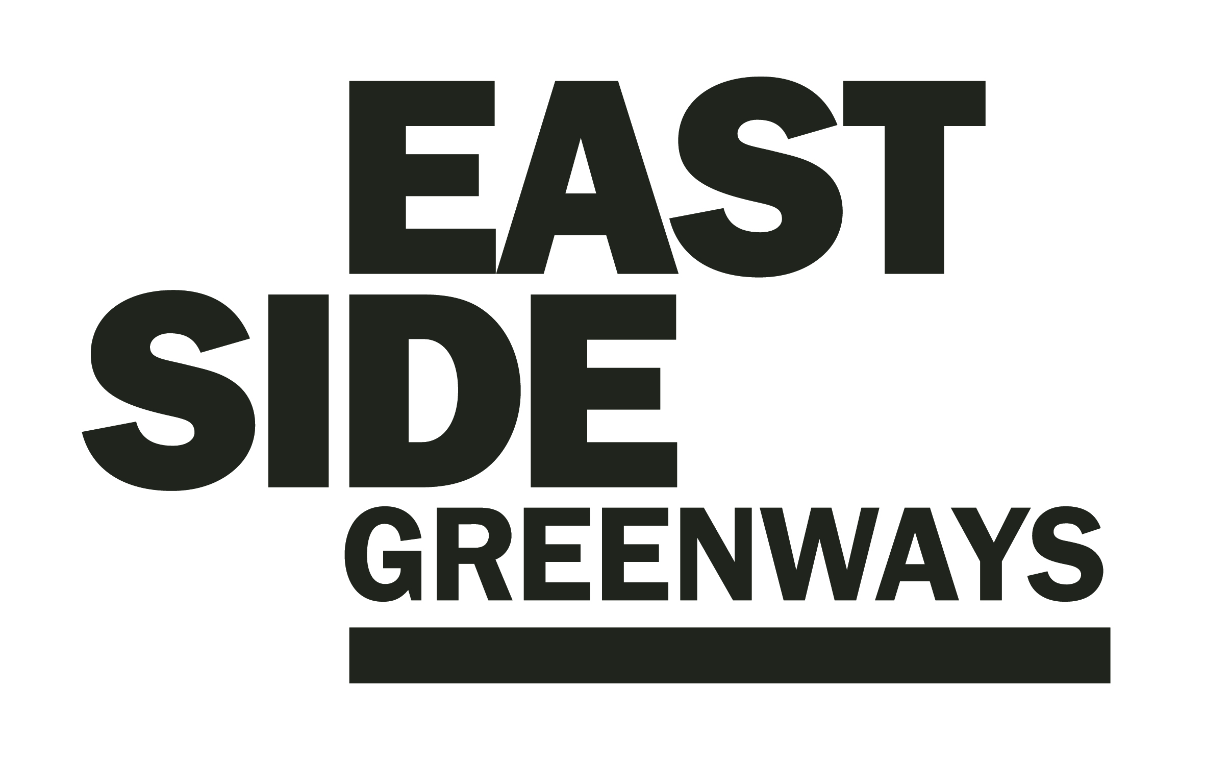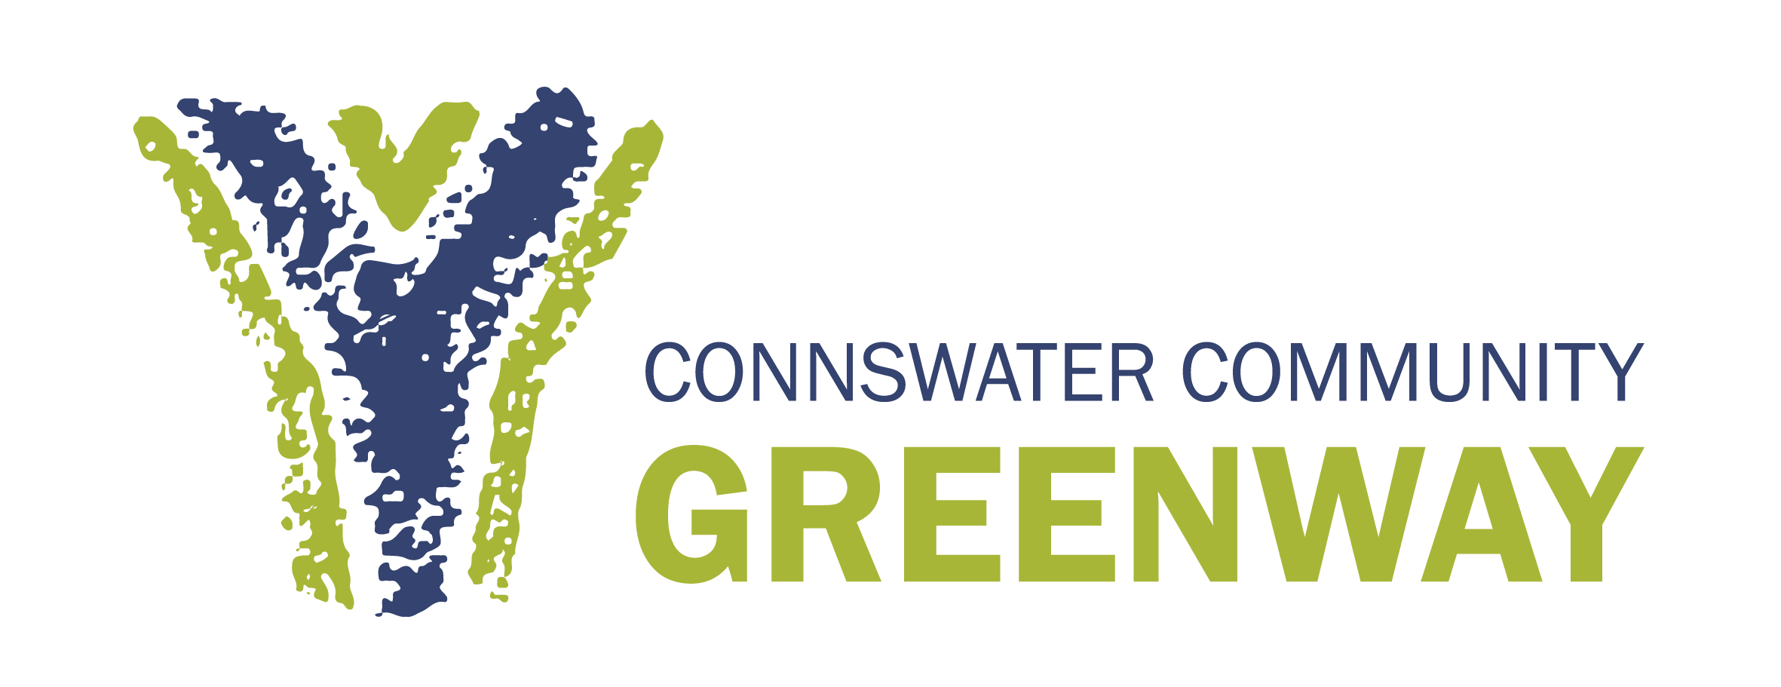

EastSide Greenway’s overall aim is to promote the use and development of green open spaces, parks, rivers and off-road transport routes in east Belfast and to act as a catalyst for the ongoing regeneration or the area.

EastSide Greenway’s strategic objectives are:

- To ensure the sustainability of the Connswater Community Greenway as a living landmark
- To promote the potential for and facilitate the delivery of a wider ‘EastSide Greenways’ network
- To maximise the potential of the Connswater Community and EastSide Greenways to contribute to EastSide’s overarching strategy to deliver social and economic benefit, and enhanced health and well being
- To use the Connswater Community and EastSide Greenways as a catalyst for economic regeneration in east Belfast
- Create new opportunities and promote well - being through the active engagement of local communities and the wider public
- To enhance and conserve the environment along the Connswater Community and EastSide Greenways.

To find out more please visit: www.eastsidegreenways.com

