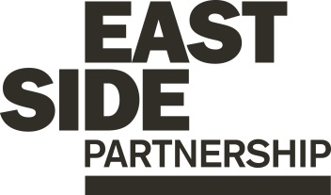

Job Description ESP/ESACP26

Project: EastSide Arts

Job Title: Creative Producer

Location: EastSide Partnership, Avalon House

Reports to: Cultural Development Manager

Terms and conditions

Salary: Annual salary of £32,061 (Pro Rata £25,648 based upon 30 hours/week), plus 7.5% employer pension contribution.

Annual salary increments are agreed by the Board of Directors.

Contract: This is a permanent post, subject to receipt of future funding

Job subject to 6-month probation period.

Holidays: 25 days per year (pro rata) plus statutory holidays.

Hours of work: Part time – 30 hours per week. Availability to work flexible hours including some evenings and weekends is essential to this role

The following gives an indication of the current main duties and responsibilities of the post. The post holder will be expected to work flexibly and carry out any other duties appropriate to the role which may reasonably be required from time to time.

About the role
We are looking for an enthusiastic and organised team player to help plan and deliver EastSide Arts’ year‑round programme and the annual EastSide Arts Festival, developing high‑quality, inclusive and accessible events that support artists, expand opportunities for creativity, and animate spaces across east Belfast.

The Creative Producer will work closely with the EastSide Arts Cultural Development Manager and Project Officer through all stages of programming and production and will play a key role in growing the scale and variety of our cultural offering.

Summary of responsibilities

- Coordinate the production of EastSide Arts events, with support from the wider EastSide team.
- Ensure high standards across all aspects of planning, delivery and evaluation while liaising closely with our production partners and contractors.
- Contribute to EastSide Arts’ collaborative programming processes, bringing strong sectoral knowledge and networks to the curation of our events, whilst ensuring that our programme is inclusive, accessible and consistent with the values, business plan and strategic objectives of EastSide Arts and EastSide Partnership.
- Support the co-creation of events with our many programming partners.
- Contract artists, suppliers, freelancers, venues and technical teams, ensuring all agreements, insurances and certifications are in place.
- Build and sustain strong working relationships with a wide range of stakeholders including artists, venues and partners in relation to creative activities in east Belfast.
- Support the Cultural Development Manager in scoping and developing new projects and events as EastSide Arts continues to strengthen its year-round programme.
- Coordinate artist liaison during EastSide Arts Festival, ensuring all our artists have a smooth, supported experience while working with us.
- Support the Cultural Development Manager in the preparation and implementation of risk assessments, event management plans and other documentation.
- Contribute to the coordination and support of our dedicated EastSide volunteers, who we engage throughout our festival and year-round programme.
- Support the Cultural Development Manager in the monitoring and management of programming budgets including funding applications, and ensuring that all reporting is completed in a timely manner.
- Support the Cultural Development Manager in the sourcing and completion of grant funding applications to ensure that EastSide Arts’ programming is appropriately resourced, carrying out financial management and monitoring as required.
- Work collaboratively with EastSide Partnership colleagues to ensure that EastSide Arts’ cultural programme is contributing to a thriving, connected and welcoming East Belfast
- To undertake any other relevant duties as may be required.

Person Specification ESP/ESACP26

 | Essential | Desirable
Experience | - A minimum of 2 years’ experience gained in the past 5 years of;  Production and programming of high-quality arts and cultural events and/ or festivals andacross multiple art forms and venues  Community engagement and co-creation practices  Artist commissioning, developing briefs, contracts and supporting artists through the production process  Experience of budget and resource management across single events and/ or festivals | - Experience of;  Event management plans, Health & safety, risk assessments, licensing and compliance  Use of ticketing systems
Skills | Excellent interpersonal and communication skills with the ability to establish and maintain relationships with a broad range of stakeholders  Ability to be creative, innovative and work on own initiative  Effective organisation skills with the ability to manage and prioritise workload and meet deadlines  Excellent administration and reporting skills including use of Excel, PowerPoint and Word  Ability to work independently while contributing to a collaborative team | Impact measurement and data analysis  Ability to contribute to marketing and communications, including writing copy and shaping narratives around creative programmes.
Knowledge & Values | Excellent knowledge of the local and regional arts and culture sector  Commitment to regeneration and a partnership approach.  Commitment to diversity, equity, inclusion and accessibility. | Experience of community development and/or cultural regeneration practices.  Understanding of audience development strategies  Knowledge of EastSide Arts and EastSide Partnership
Circumstances | Willingness to work flexible hours including evenings and weekends  Able and willing to travel across Belfast for work purposes

Application Process ESP/ESACP26

Application
- Completed applications must arrive by 12pm on Wednesday 18th February

- Applications will only be accepted by email to gillian@eastsidepartnership.com and will be acknowledged by email. If not acknowledged please contact Gillian on 028 9045 1900

- Please complete the application form and monitoring form, CVs will not be accepted.

- To be accepted the application MUST include the monitoring form

- We may only interview those applicants who appear, from the information provided, to be the most suitable in terms of the person specification provided.

Equal Opportunities
- EastSide Partnership is an equal opportunities employer. EastSide Partnership does not permit unlawful discrimination of any kind against any person on grounds which include gender, sexual orientation, marital status, religious belief or political opinion, race or disability. Unlawful discrimination is defined as treating a person less favourably than others are, or would be treated in the same or similar circumstances.

Canvassing
- Canvassing in any form will, if proved to the satisfaction of EastSide Partnership, disqualify a candidate for the appointment.

Interviews
- Interviews will be held on Wednesday 25th February. Please ensure your availability for interview on this date prior to application, as it will not be possible to arrange an alternative date.

Job Description
- The duties outlined in the Job Description serve as a guide to the current and major responsibilities of the post. These will inevitably vary as the role develops and the Job Description will be reviewed on a regular basis. Changes will be subject to consultation with the post holder.

Background Information

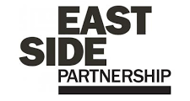

EastSide Partnership (ESP) is a charity leading the regeneration of east Belfast. We work alongside community-based organisations, elected representatives, statutory agencies and local businesses, to deliver a wide variety of projects seeking to benefit residents, visitors and our neighbours.

Vision
A thriving, connected and welcoming east Belfast which is –
- Economically thriving; a community where people want to live, work and invest
- Connected; bringing local people together at an individual and neighbourhood level, as well as being connected to the rest of the city, and to our neighbours and beyond
- Welcoming; bringing visitors to the area to celebrate east Belfast

Mission

To improve quality of life in east Belfast

We believe our mission is to improve the lives of people across east Belfast and that means working on a range of projects.
- Helping local people to have a say in what happens in their lives and in their local area
- Supporting people who are most in need to improve their life changes and take opportunities
- Encouraging everyone in east Belfast to enjoy green space and culture
- Celebrating the diverse cultures of east Belfast
- Welcoming new people to visit and live in the area

Strategic Priorities
- To lead on and advocate fore the regeneration of east Belfast
- To facilitate and co-ordinate relevant partners to work together for the regeneration of east Belfast
- To improve and animate the built and natural environment of east Belfast
- To improve the life changes and opportunities of the most in need in east Belfast
- To be a sustainable effective organisation
- To develop, celebrate and promote the culture, creativity and heritage of east Belfast

For more information please visit www.eastsidepartnership.com

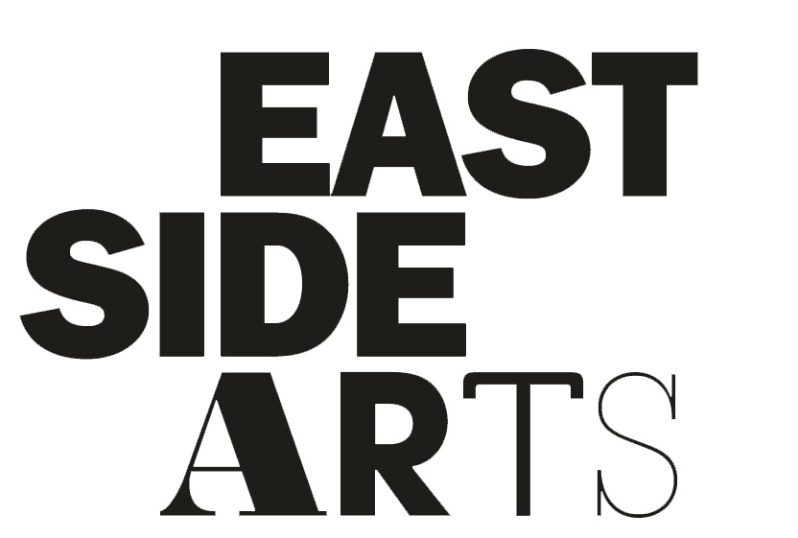

EastSide Arts, a subsidiary company of EastSide Partnership, seeks to create an east Belfast that is a thriving cultural hub; where the arts are valued, creativity is for everyone and people are connected with each other and the wider world.

Our objectives for 2025/26 are:
Objective 1: Artists are supported to work in east Belfast:
- Artists are part of the fabric of the community
- The arts are seen as a valid career choice
- Artists are supported to make work
Objective 2: Increased diverse opportunities for people to be creative, on their terms
- More creative things happening in east Belfast, and more people doing them
Objective 3: More places in east Belfast are animated with creative activities
- Non-arts spaces are fit for arts purposes and are accessible to everyone
- Non-traditional arts spaces are animated with arts events by ESA and others
Objective 4: ESA has strong governance in place
- ESA maintains an optimum level of committed, capable trustees with oversight of the company
- ESA has a committed team of employees who are capable and have capacity to deliver the Objectives
- ESA is financially sustainable

EastSide Arts promotes and encourages appreciation for and active participation in arts and cultural activities and aims to stimulate the creativity of people in east Belfast and beyond.

We do this by devising and delivering a comprehensive year-round programme of events and the annual EastSide Arts Festival. Community is at the heart of everything we do and all of our programmes and events are delivered in partnership with local artists, venues, community groups and businesses.

More information: www.eastsidearts.net

